

D6b Final Validation Report Part 2

Prepared exclusively for the U.S. Food and Drug Administration

Table of Contents

List of Tables ii

List of Figures ii

1 Executive Summary 3

2 Introduction 4

3 Constraints and Limitations 4

4 Materials Validation 5

4.1 Documentation 5

4.2 Major Findings 5

5 Review of Harvard Grant Team Responses to Model Verification #2 7

6 Review of Harvard Grant Team Responses to Final Validation Part 1 7

7 Policy Validation 8

7.1 Background 8

7.2 Methods 8

7.3 Summary of Findings 9

7.4 Use Cases 9

7.5.1 Increasing Naloxone Availability 9

7.5.2 Treatment Expansion 15

7.5.3 Combination of Increasing Nx Availability and Treatment Expansion Policies 20

8 Model Comparator 26

8.1 Comparison with Homer and Wakeland 2020 26

8.1.1 Core Model Logic and Structure 29

8.1.2 Key Conceptual Feedback Structure 30

8.1.3 Treatment 30

8.1.4 Opioid Supply 31

8.1.5 Overdoses, Deaths, and Naloxone 31

8.1.6 Heroin 32

8.2 Policy Comparison 32

9 Conclusion 34

9.1 Summary of Findings 34

9.2 Summary of Recommendations 35

9.3 Usability Assessment 37

10 References 38

11 Appendix 39

11.1 Policy Validation Graphs and Tables 40

11.2 Statement of Work Checklist 43

List of Tables

Table 4‑1: Materials Validation Findings 6

Table 5‑1: Review of Response to Model Verification #2 7

Table 7‑1: Policy Interventions Tested for Increasing Naloxone Availability 10

Table 7‑2: Policy Interventions Tested for Treatment Expansion 16

Table 7‑3: Policy Interventions Tested for Combination of Increasing Naloxone Availability and Treatment Expansion 21

Table 8‑1: Model Comparison Between Model v1110 and the HWM 27

Table 8‑2: Policy Comparison Between Model v1110 and the HWM 33

Table 11‑1: Results of Increasing Naloxone Kits Distributed for Rx and Heroin Users on the Probability of OD death not averted for Different Scenarios 41

Table 11‑2: Results of Increasing Treatment Seeking Rate on the Overdose Deaths Among Individuals with HUD and Rx OUD for Different Scenarios 41

Table 11‑3: Simulation Results and Percentage Changes Over Baseline at 2030 for Different Interventions Individually or Combined 42

Table 11‑4: SOW Checklist 43

List of Figures

Figure 7‑1: Result of Increasing Probability Nx bystander Rx (ID 2) on Total overdose deaths Rx 11

Figure 7‑2: Result of Increasing Probability Nx bystander heroin (ID 5) on Total overdose deaths heroin 11

Figure 7‑3: Results of Increasing the Probability that Naloxone is Available to Rx Bystanders (ID 2) to 20% 12

Figure 7‑4: Results of Increasing Nx Availability to both Rx and Heroin Bystanders (ID 6) to 25% from the Baseline Nx Availabilities of 4.7% for Rx Bystanders and 22% for Heroin Bystanders 13

Figure 7‑5: Result of Increasing Probability Nx bystander Rx (ID 2) on Probability OD death not averted heroin and Rx user 14

Figure 7‑6: Result of Increasing Probability Nx bystander heroin (ID 5) on Probability OD death not averted heroin and Probability OD death not averted Rx user 14

Figure 7‑7: Results of Increasing the Treatment Capacity (ID 9) by 20% 17

Figure 7‑8: Number of People with HUD in MOUD Tx for Bup, MMT, and Viv for Different Increases in Treatment Capacities (ID 9). 18

Figure 7‑9: Number of People with HUD in MOUD Tx for Bup, MMT, and Viv for the Scenario Only Increasing MMT Capacity by 20% 18

Figure 7‑10: Number of People with HUD in MOUD Tx for Bup, MMT, and Viv for the Scenario Only Increasing Viv Capacity by 20% 19

Figure 7‑11: Results of Increasing the Duration of the Treatments on Different Output Variables (ID 7) 19

Figure 7‑12: Results of Increasing Probability of Nx Bystander for Rx Users to 20% and Increasing Treatment Capacity by 20% (ID 13, Scenario 1) 22

Figure 7‑13: Number of People with HUD when Increasing Tx Capacity and Probability Nx Bystander (ID 13) 23

Figure 7‑14: Results of Increasing Probability of Nx bystander for Rx users to 20% and Increasing Treatment Seeking Rate to 0.65 (ID 11, Scenario 1) 23

Figure 7‑15: Number of People with HUD not in MOUD Tx and HUD total When Increasing Tx Seeking Rate and Probability Nx Availability Bystander (ID 11) 24

Figure 7‑16: Number of Overdose death HUD in MOUD Tx[Bup] When Increasing Tx Seeking Rate and Probability Nx Availability Bystander (ID 11) 25

Figure 7‑17: Number of Overdose death Rx OUD no H in Tx[Bup] When Increasing Tx Seeking Rate and Nx Availability Bystander (ID 11) 26

Figure 11‑1: Graph-Over-Time Plots of Total overdose deaths Rx, Total nonfatal overdoses, and Total overdose deaths for Different Interventions and Scenarios Individually or Combined 40

# Executive Summary

The D6b Final Validation Part 2 details our high-level findings and recommendations for the U.S. Food and Drug Administration’s (FDA) opioid systems dynamics model version “OSM_Master_1110” (hereinafter “model v1110”) submitted by the Harvard Medical School Grant Team (hereinafter “Grant Team”) on November 12, 2020. The objectives of Final Validation Part 2 were to: 1) review and verify updates resulting from Final Validation Part 1 feedback; 2) verify technical documentation is complete and accurate; 3) certify the model adheres to sounds modeling principals; and 4) provide an un-biased evaluation of the model’s readiness to be used in FDA decision-making. For Part 2, we focused our activities around: 1) a review of the Grant Team’s responses to Model Verification #2 related to policy validation; 2) a review of the Grant Team’s responses to Final Validation Part 1 findings; 3) policy validation; and 4) model comparator. The following is a list of key findings and recommendations from this report:

1. We found that model v1110 enables the model user to easily generate results to assess combined opioid policies and to rigorously evaluate results by adjusting output variables as necessary.
2. We found that model v1110 results were generally intuitive, and we did not identify any scenarios where the model produced results that were qualitatively inconsistent with previously published results.
3. We found that model v1110 compares favorably with the Homer and Wakeland 2020 Model (hereinafter “HWM”); the structure of model v1110 is consistent with and has additional important and useful details and complexity compared to the HWM.
4. We found that model v110 is suitable for use in evaluating a variety of policies related to opioid interventions.
5. We recommend enhancing information around model limitations and assumptions in the appropriate documentation.
6. We recommend providing justification for setting the value of nonfatal overdose risk (i.e., **Perceived risk weight NFOD**) to 0.1 or increasing the value to at least 0.5.
7. We found differences in both the magnitude and dynamics of elements related to street supply disruptions compared to HWM. We recommend further exploration of these differences to check for proper implementation of this area of the model.
8. We found that model v1110 operates on the assumption that there is no feedback from capacity utilization that affects individuals’ decisions for seeking one treatment versus another. We recommend this area of the model be considered for further adjustment or development; addressing limitations in the treatment area of the model could lead to increased confidence in the model's results.

# Introduction

System dynamics subject matter expert (SME) Jack Homer, Ph.D., and Booz Allen previously reviewed versions 406b, 511, and 622 of FDA’s model and documented findings and recommendations in the [Initial Validation Report](http://sharepoint.fda.gov/orgs/CDER-OPSA/PEIS/opioidspolicytool/Shared%20Documents/Opioids%20Policy%20Tool/D06ab%20-%20Initial%20Validation%20Report%20+%20Final%20Validation%20Report/D6a_Initial%20Validation_Report_202003270110.docx), [Model Verification #1](http://sharepoint.fda.gov/orgs/CDER-OPSA/PEIS/opioidspolicytool/Shared%20Documents/Opioids%20Policy%20Tool/D06ab%20-%20Initial%20Validation%20Report%20+%20Final%20Validation%20Report/D6b_ModelVerification1_202005290841.docx), and [Model Verification #2](http://sharepoint.fda.gov/orgs/CDER-OPSA/PEIS/opioidspolicytool/Shared%20Documents/Opioids%20Policy%20Tool/D06ab%20-%20Initial%20Validation%20Report%20+%20Final%20Validation%20Report/D6b_ModelVerification2_20207101030.docx) respectively. For Final Validation Part 1, a Validation Team comprised of Brad Morrison, Ph.D., and Booz Allen modelers and analysts reviewed model v831 and documented findings and recommendations in the [Final Validation Part 1 Report](http://sharepoint.fda.gov/orgs/CDER-OPSA/PEIS/opioidspolicytool/Shared%20Documents/Opioids%20Policy%20Tool/D06ab%20-%20Initial%20Validation%20Report%20+%20Final%20Validation%20Report/D6b_Final%20Validation%20Part%201_Report_202009302130.docx). For Final Validation Part 2, the Validation Team evaluated v1110 of the model to: 1) review and verify updates resulting from Final Validation Part 1 feedback; 2) verify technical documentation is complete and accurate; 3) certify the model adheres to sounds modeling principals; and 4) provide an un-biased evaluation of the model’s readiness to be used in FDA decision-making. We present the following sections in this document:

* Validation Constraints and Limitations
* Materials Validation
* Review of Harvard Grant Team Responses to Model Verification #2
* Review of Harvard Grant Team Responses to Final Validation Part 1
* Policy Validation
* Model Comparator
* Conclusion

# Constraints and Limitations

System dynamics model validation can be limited by the nature of the modeling itself which allows for a range of approaches (Homer 2019). The absence of a standardized system dynamics modeling approach and prescriptive validation process can make it challenging to compare validation findings between different versions of a model. We attempted to address this by following our [Validation Plan](http://sharepoint.fda.gov/orgs/CDER-OPSA/PEIS/opioidspolicytool/Shared%20Documents/Opioids%20Policy%20Tool/D05%20-%20Validation%20Plan/D5_Validation%20Plan_Updated_202001170446.docx), which provided a systematic, reproducible, and adaptable model validation framework.

While there are many ways to validate a model, the Validation Plan focuses on the most relevant validation activities and tests as highlighted by the literature (Department of Defense 2018; Sterman 2000). Select tests and standards require judgment from SMEs. SME judgement is necessary where there is no standard test or metric described in the literature to assess appropriateness or reasonableness for a component of the model.

To make efficient use of resources while providing an impactful validation, Part 2 of the Final Validation is not exhaustive (i.e., we did not review every single policy lever in the model). However, the validation was thorough, and there are sufficient findings to substantiate a strong base model.

We outline the constraints and limitations of the report below:

* **Validation Process** **-** This is the first time FDA has implemented an opioid system dynamics model for policy analysis which limited the Validation Team in comparing and contrasting the results of all the performed tests with other preexisting results or studies. Instead, the team conducted qualitative and quantitative use case testing that was informed by previous interviews with FDA stakeholders and scenarios tested in the HWM. For policy validation tests, we focused on interventions related to increasing naloxone (Nx) availability and treatment (Tx) expansion. We also performed tests including the combinations of these two policies.
* **Validation Findings** - The Final Validation Part 2 Report is only relevant to model v1110. If model development has progressed (e.g., addition of new components, changing the structure of the current model) since the Validation Team began validation, findings and recommendations may no longer be relevant.
* **Review of Data Processing Files** – Final Validation Part 2 materials validation focused on verifying that documentation necessary for model validation was available and complete rather than reviewing supporting documentation for how constants in the model were calculated. The data processing files and related data documentation sent by the Grant Team will be assessed as part of model maintenance activities.

# Materials Validation

The Validation Team performed the materials validation to verify documentation and technical materials (e.g., model files) necessary for model validation were available, complete, and accurate. We used these materials to understand the scope of model v1110 including assumptions, capabilities, and limitations of model v1110.

## Documentation

On November 12, 2020, the Validation Team received model v1110 for validation. This package included:

* **Vensim Model File**
* **Documentation Master File.xlsx –** This document is hereinafter referred to as “documentation.” It contains: information on model variables and assumptions; a list of model equations; a hard copy of input time series; validation time series; and calibration weights; and background on background on data analysis.
* **Combined Modeling Files.xlsx –** This document includes data transformations and source data.We will assess this file during the next model maintenance cycle.
* **NSDUH for Documentation 11062020.sas** - SAS code required for transformation of NSDUH data. We will assess this file during model maintenance.
* **Input Time Series and Validation Series** - The time series are included in .vdfx files delivered alongside the Vensim model.
* **Sensitivity Files Graphs** – A series of graphs that show the sensitivity of outcomes with respect to value changes of model parameters.
* **Bibliography -** This Word document contains a list of the supporting literature used in the model.

We updated the “Materials Validation” tab in [Version 2 of the Final Validation Part 1 Findings punch list](http://sharepoint.fda.gov/orgs/CDER-OPSA/PEIS/opioidspolicytool/Shared%20Documents/Opioids%20Policy%20Tool/D06ab%20-%20Initial%20Validation%20Report%20+%20Final%20Validation%20Report/D6b_Final%20Validation%20Part%201_Findings_v2_202012162000.xlsx) to provide a summary evaluation of the validation documents listed above.

## Major Findings

Overall, the documentation includes sufficient technical details such as inputs, model variables, and data transformations. However, the documentation includes limited information and discussion around model assumptions, capabilities, or limitations (see Table 4‑1). In the documentation for model v831, the cover letter and model overview PowerPoint contained these details. While it is likely that the old versions of these files remain mostly accurate, it is important for updated versions to be included as part of the documentation. These documents are essential for proper interpretation of model outputs.

Table 4‑1: Materials Validation Findings

|  |  |  |  |
| --- | --- | --- | --- |
| Validation Type | Finding | Discussion of Finding | Recommended Actions |
| Materials Validation | Lack of material relating to model assumptions, capabilities, and limitations. | These aspects of the documentation were previously part of the cover letter as well as the model overview PowerPoint, but those documents were not included with v1110 of the model. We note that some specific assumptions are included in the Excel files, but there is not broader discussion around assumptions and their implications. | Include updated versions of the cover letter and model overview PowerPoint. |

# Review of Harvard Grant Team Responses to Model Verification #2

This section summarizes the review of model v1110 against [Model Verification #2](http://sharepoint.fda.gov/orgs/CDER-OPSA/PEIS/opioidspolicytool/Shared%20Documents/Opioids%20Policy%20Tool/D06ab%20-%20Initial%20Validation%20Report%20+%20Final%20Validation%20Report/D6b_ModelVerification2_20207101030.docx) feedback related to policy validation. Table 5‑1 summarizes our review of those Model Verification #2 findings.

Table 5‑1: Review of Response to Model Verification #2

| Verification #2 Finding Based on Model v622 | Review of Finding in Model v1110 |
| --- | --- |
| Assumptions regarding street prescription (Rx) consumption that lead to unexpected behavior in the model. | Current model includes assumptions consistent with Verification #2 recommendations. |
| The model did not reasonably follow historical values of: 1) buprenorphine (Bup) treatment from 2014-2018; and 2) prices of illicit prescriptions (Rx) on the streets. | Simulated Bup treatment peaks in 2019 and declines slightly. This is beyond the range of data, which does not show a peak yet. Please document uncertainty about future Bup treatment and consider a review when more recent data is available.  Simulated Rx prices fit data much better in model v1110. |
| We found strong assumptions in the baseline run of the model may lead to improbable baseline run estimates for the “business-as-usual” scenario. | Revisions include improved assumptions that lead to more reasonable estimates in the “business-as-usual” scenario. |

# Review of Harvard Grant Team Responses to Final Validation Part 1

This section summarizes the review of model v1110 against Final Validation Part 1 feedback related to structural and behavioral validation. Please see [Final Validation Part 1 Findings Version 2](http://sharepoint.fda.gov/orgs/CDER-OPSA/PEIS/opioidspolicytool/Shared%20Documents/Opioids%20Policy%20Tool/D06ab%20-%20Initial%20Validation%20Report%20+%20Final%20Validation%20Report/D6b_Final%20Validation%20Part%201_Findings_v2_202012162000.xlsx) for the Validation Team’s full list of responses and recommended follow-up actions.

In general, the Grant Team’s responses to Final Validation Part 1 feedback are satisfactory. However, there were several items for which we have recommended that the Grant Team include specific documentation of the relevant model characteristics. In addition, most of the Grant Team’s responses provided extra detail regarding model behavior. We recommend that these responses be documented in the appropriate files (e.g., “Model Documentation File.xlsx,” a list of assumptions, model scope brief). We have identified which responses or information from the Grant Team should be added to the documentation and where they should be added in column I and J of the Final Validation Part 1 Findings Version 2 “Model Actions” tab.

# Policy Validation

The Validation Team qualitatively and quantitatively tested imagined opioid policies using model v1110. We evaluated the results against similar published and available models: Pitt (2018); the HWM; and the work Mike Irvine, Ph.D., and Traci Green, Ph.D., M.S.C., presented at the October 22, 2020 Duke-Margolis Center for Health Policy Assessing and Incorporating Intervention Effectiveness in Systems Models of the Opioids Crisis meeting (i.e., 2020 interagency meeting). Through that evaluation, we determined some of the ways in which model v1110 contributes additional insights into the dynamics of the opioid crisis.

## Background

FDA’s opioid systems model is not intended to replace FDA’s opioid policy (i.e., public health actions) analysis activities. Instead, the model provides perspective on the multi-year intended and unintended consequences of opioid policies. This type of validation is an important opportunity to assess whether the current version of the model can answer the kinds of questions FDA asks when conducting opioid policy analyses.

## Methods

In the policy validation, we tested sets of imagined policies targeting two types of interventions in the model: 1) increasing naloxone availability; and 2) expanding treatment. We also tested these two types of interventions in combination.[1] For each imagined policy, we considered different model inputs (different interventions) and tested several scenarios to show results for different degrees of change in naloxone availability or treatment expansion. We adjusted policy levers (specific model variables related to policy) in order to set the model inputs to their appropriate values for each scenario.

For naloxone availability, we considered the following inputs: **Nx kits distributed Rx user net**, **Nx kits distributed heroin (H) user net**, **Probability Nx bystander Rx**, and **Probability Nx bystander heroin**. These inputs were adjusted for different scenarios by using two policy levers: **Policy change Nx kits distributed Rx user** and **Policy change Nx kits distributed H user**; we set the value of these two levers such that the model inputs reached the necessary values. The scenarios involved increasing the value of the inputs by a certain percent compared to baseline (when changing naloxone kits distributed) or increasing the value of the inputs to a certain value (when changing probability naloxone bystander). To allow comparison of results, we chose scenarios that included the values used in previous publications.

For treatment capacity, we considered the following inputs: **Tx average duration net**, **Tx seeking rate Rx opioid use disorder (OUD) no H total net**, **Bup total theoretical capacity**, **methadone (MMT) capacity estimated**, and **vivitrol (Viv) capacity estimated.** We adjusted the inputs for different scenarios by using the following five policy levers: **Policy change Tx average duration**, **Policy change Tx seeking rate Rx OUD no H total**, **Policy change Bup total theoretical capacity**, **Policy change MMT capacity,** and **Policy change Viv capacity**; we set the values of these five levers such that the model inputs reached the necessary values. The scenarios involved increasing the value of the inputs by a certain percent compared to baseline (when changing treatment duration and treatment capacity) or increasing the value of the inputs to a certain value (when changing treatment seeking rate).

For combining naloxone availability and treatment capacity interventions, we performed the above procedures simultaneously.

## Summary of Findings

In general, the results of the policy tests for increasing naloxone availability and treatment expansion were intuitive, and there are no major findings in this part of Final Validation Part 2. We tested policies related to increasing naloxone availability (i.e., increasing number of distributed naloxone kits among Rx and heroin users and increasing probability of naloxone available for Rx and heroin bystanders) and treatment expansion (i.e., increasing treatment capacity, treatment seeking rates, and treatment duration) individually and in combination in order to test manipulating multiple policy levers at a time.

An important finding to note is that increasing naloxone availability was the only intervention that resulted in an increase in **Total nonfatal overdoses** (see Figure 11‑1 and Table 11‑3 in the Appendix). This finding is consistent withHomer and Wakeland (2020) finding. We also found that a combination of these policies (i.e., increasing naloxone availability and expanding treatment) can more effectively reduce the number of overdose deaths compared to each policy individually. However, combining these two policies led to a greater increase in **Total heroin initiation** compared to either policy alone. Comparing interventions for increasing treatment capacity versus increasing treatment seeking rates suggests that addressing the barriers to treatment (e.g., insurance coverage) may have a greater impact than increasing treatment capacity. Additionally, interventions including increasing naloxone availability reduce **Total overdose deaths Rx** more compared to interventions limited to only expanding treatment (see Figure 11‑1 in the Appendix).

We compared the results for the intervention increasing number of naloxone kits distributed in model v1110 with Irvine and Greene (2020); our findings from model v1110 were qualitatively consistent with the findings Irvine and Green presented. We also compared our results from increasing naloxone availability and treatment expansion interventions in model v1110 with Pitt (2018). Our findings from model v1110 were qualitatively consistent with the Pitt (2018) findings as well.

Although there are some limitations in the treatment part of the model, the model still provides value to understanding the short- and long-term effects of the interventions. For example, in the current version of the model, relative availability does not influence the choice of which therapy to seek. There is no feedback from capacity utilization that affects individuals’ decisions for seeking one treatment versus another. In another words, if a person seeks one therapy and cannot get it, they will not seek another method. Therefore, this could be an area in the model that may benefit from further adjustment or development. Addressing this limitation on the treatment area of the model could lead to increased confidence into the model's results.

## Use Cases

### 7.5.1 Increasing Naloxone Availability

We tested several scenarios related to policies aiming to increase naloxone availability. Table 7‑1 lists samples policy questions, inputs to the model that relate to those policy questions, and the changes to those inputs (i.e., scenarios) that we tested. We used policy levers to adjust the inputs accordingly. The input variables include increasing the probability that a bystander to an Rx and/or heroin overdose has naloxone available and increasing the number of naloxone kits distributed for Rx and/or heroin users. We tested these input variables alone or in combinations, as specified in Table 7‑1. Informal, supplemental results, including graph-over-time plots for all the policies and scenarios in Table 7‑1, can be found in the [GeneratingScenario.zip](http://sharepoint.fda.gov/orgs/CDER-OPSA/PEIS/opioidspolicytool/Shared%20Documents/Opioids%20Policy%20Tool/D06ab%20-%20Initial%20Validation%20Report%20+%20Final%20Validation%20Report/GeneratingScenario.zip) file.

Table 7‑1: Policy Interventions Tested for Increasing Naloxone Availability

| ID | Policy Category | Policy Question | Input | Changes to Input (2020-2030) | Baseline Value |
| --- | --- | --- | --- | --- | --- |
| 1 | Increasing Naloxone Availability | What if naloxone was universally available over-the-counter?  What if harm reduction and treatment programs distributed naloxone for free? | **Nx kits distributed Rx user net** | Increase by:  5%, 20%, 25%, 50% | 296,785 (people/year) |
| 2 | Increasing Naloxone Availability | What if the probability of naloxone administration by bystanders increased?  What if naloxone was universally available over-the-counter? What if harm reduction and treatment programs distributed naloxone for free? What if the price of naloxone decreased? | **Probability Nx bystander Rx** | Increase to the following values:  5%, 20%, 25%, 50% | 4.7% |
| 3 | Increasing Naloxone Availability | What if naloxone was universally available over-the-counter? What if harm reduction and treatment programs distributed naloxone for free? | **Nx kits distributed H user net** | Increase by:  5%, 20%, 25%, 50% | 1.823 M (people/year) |
| 4 | Increasing Naloxone Availability | What if naloxone was universally available over-the-counter? What if harm reduction and treatment programs distributed naloxone for free? | **Nx kits distributed Rx user net & Nx kits distributed H user net** | Increase by:  5%, 20%, 25%, 50% | 296,785  &  1.823 M respectively |
| 5 | Increasing Naloxone Availability | What if the probability of naloxone administration by bystanders increased?  What if naloxone was universally available over-the-counter? What if harm reduction and treatment programs distributed naloxone for free? What if the price of naloxone decreased? | **Probability Nx bystander heroin** | Increase to the following values:  25%, 50% | 22% |
| 6 | Increasing Naloxone Availability | What if the probability of naloxone administration by bystanders increased?  What if naloxone was universally available over-the-counter? What if harm reduction and treatment programs distributed naloxone for free? What if the price of naloxone decreased? | **Probability Nx bystander Rx** & **Probability Nx bystander heroin** | Increase each to the following values:  25%, 50% | 4.7%  &  22% respectively |

Overall, the results of the naloxone policy testing were intuitive. We considered individually increasing naloxone accessibility to Rx users and heroin users (in policy IDs 1, 2, 3, and 5) to distinguish between their effects, even though the two probabilities may increase together in reality. Individually increasing the probability that naloxone is available to Rx and heroin bystanders respectively resulted in decreases to overdose deaths for Rx users (i.e., **Total overdose deaths Rx**) and heroin users (i.e., **Total overdose deaths heroin**) relative to baseline, as expected (see Figure 7‑1 and Figure 7‑2). The effect of decreased **Total overdose deaths** relative to baseline is immediate and remains until the end of the simulations (2030).

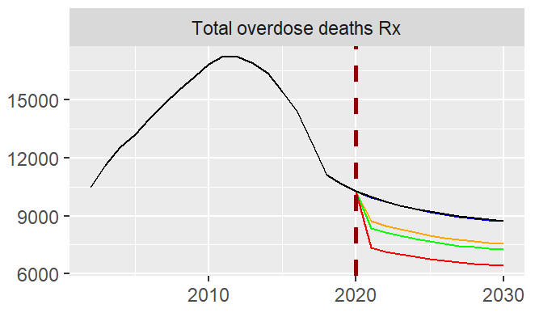

Figure 7‑1: Result of Increasing Probability Nx bystander Rx (ID 2) on Total overdose deaths Rx

*Note: x-axis = year; y-axis = number of people. The vertical line designates the scenario start year. The colored lines represent different input values (here,* ***Probability Nx bystander Rx****) during each analysis: Baseline (4.7%, black), scenario 1 (5%, blue), scenario 2 (20%, orange), scenario 3 (25%, green), and scenario 4 (50%, red).*

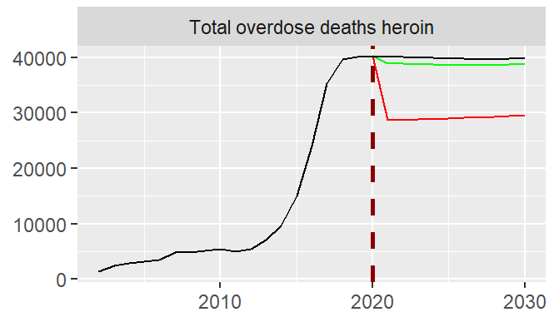

Figure 7‑2: Result of Increasing Probability Nx bystander heroin (ID 5) on Total overdose deaths heroin

*Note: x-axis = year; y-axis = number of people. The vertical line designates the scenario start year. The colored lines represent different input values (here input is* ***Probability Nx bystander heroin****) during each analysis: Baseline (22%, black), scenario 1 (25%, green), and scenario 2 (50%, red).*

Increasing naloxone availability to Rx bystanders (i.e., **Probability Nx bystander Rx**) also shows a decrease in **Total overdose deaths** relative to baseline. For an increase from 4.7% to 20% availability, **Total overdose deaths** decrease by 2.37% in 2030 (see Figure 7‑3). However, there are other effects of increasing naloxone availability.This intervention leads to an increase in **Total nonfatal overdoses** (by 0.40% compared to baseline in 2030; see Figure 7‑3), reflecting the fact that use of naloxone prevents some overdose deaths, so some that would have been fatal are now non-fatal, and overdose survivors may also overdose again. This finding is qualitatively consistent with Homer and Wakeland (2020) which also suggested that expanding naloxone to 20% reduces total overdose deaths and increases nonfatal overdoses. Additionally, the results show increases to **Total** **Rx misuse initiation** and **Total heroin initiation** by 0.78% and 0.49%, respectively (see Figure 7‑3).

One point of departure of model v1110 compared to the HWM is in the magnitude of the effect of each intervention. Increasing the probability that naloxone is available to bystanders to 20% shows that by 2030, **Total overdose deaths** decrease by 2.37% compared to the baseline, while **Rx OUD all total** increases 0.46% and **Total nonfatal overdoses** increasesby 0.40%. However, Homer and Wakeland (2020) shows that expanding naloxone reduces overdose deaths by 12%, increases persons with OUD by 2%, and increases nonfatal overdose cases by 3%.

Figure 7‑3: Results of Increasing the Probability that Naloxone is Available to Rx Bystanders (ID 2) to 20%

Increasing naloxone availability for both Rx and heroin users (i.e., **Probability Nx bystander Rx** and **Probability Nx bystander heroin**) similarly produced results as expected. The overall trend of these interventions was to reduce overdose deaths (e.g., **Total overdose deaths**) in both subpopulations but increase heroin initiation (e. g., **Total heroin initiation**), as shown in Figure 7‑4. The default value for **Perceived risk weight NFOD** was set at 0.1, which means that fatal overdoses have a larger impact on perceived risk than non-fatal overdoses. Thus, a decrease in fatal overdoses (as a result of naloxone implementation) leads to reduced risk perception of heroin use, and therefore, increased heroin initiation. In this way, adjusting **Perceived risk weight NFOD** can affect the response of heroin initiation to naloxone related policies. The [Initial Validation Report](http://sharepoint.fda.gov/orgs/CDER-OPSA/PEIS/opioidspolicytool/Shared%20Documents/Opioids%20Policy%20Tool/D06ab%20-%20Initial%20Validation%20Report%20+%20Final%20Validation%20Report/D6a_Initial%20Validation_Report_202003270110.docx) questioned the default parameter value (0.1) for nonfatal overdose risk weight (**Perceived risk weight NFOD** in model v1110), but this observation was not addressed in model v1110. We recommended documenting the justification for the weight of nonfatal overdose risk (i.e., **Perceived risk weight NFOD**) of 0.1 or increasing the weight value to at least 0.5. For more information, see the discussion of the finding and recommendation for ID 42 in the Initial Validation Report.

Figure 7‑4: Results of Increasing Nx Availability to both Rx and Heroin Bystanders (ID 6) to 25% from the Baseline Nx Availabilities of 4.7% for Rx Bystanders and 22% for Heroin Bystanders

Increasing naloxone availability to Rx bystanders or heroin bystanders has different effect sizes on averting overdose deaths. Increasing naloxone availability to Rx bystanders to 25% (shown in Figure 7‑5) reduces **Probability overdose (OD) death not averted Rx user** by 20.72% but its effect on **Probability OD death not averted heroin user** is not noticeablecompared to baseline in 2030. In contrast, increasing naloxone availability to heroin bystander to 25% (shown in Figure 7‑6) only reduces **Probability OD death not averted heroin user** by 3.06% compared to baseline in 2030. However, it is worth mentioning that the baseline value for the **Probability Nx bystander Rx** is lower than the baseline value for **Probability Nx bystander heroin.** Therefore, increasing the value to 25% is a bigger change for the Rx bystander variable compared to the heroin bystander variable. Each intervention has a small effect on averting overdose deaths of users not affected directly; increasing naloxone for Rx bystanders increased **Probability OD death not averted heroin user** by 0.02%, while increasing naloxone for heroin bystanders decreased **Probability OD death not averted Rx user** by 0.01%.

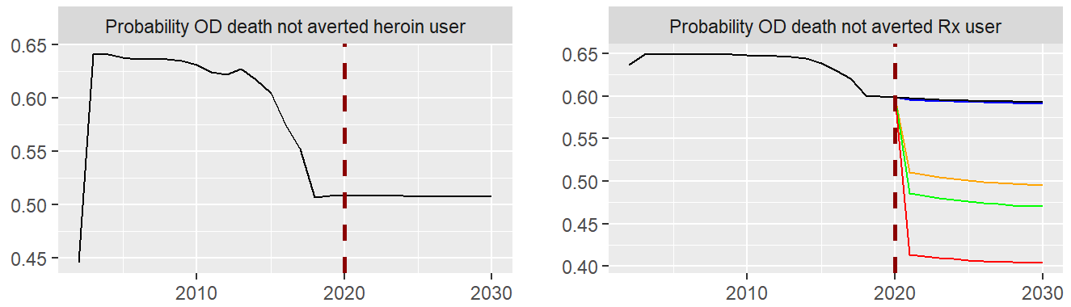

Figure 7‑5: Result of Increasing Probability Nx bystander Rx (ID 2) on Probability OD death not averted heroin and Rx user

*Note: x-axis = year; y-axis = probability. The vertical line designates the scenario start year. The colored lines represent different input values (here,* ***Probability Nx bystander Rx****) during each analysis: Baseline (4.7%, black), scenario 1 (5%, blue), scenario 2 (20%, orange), scenario 3 (25%, green), and scenario 4 (50%, red).*

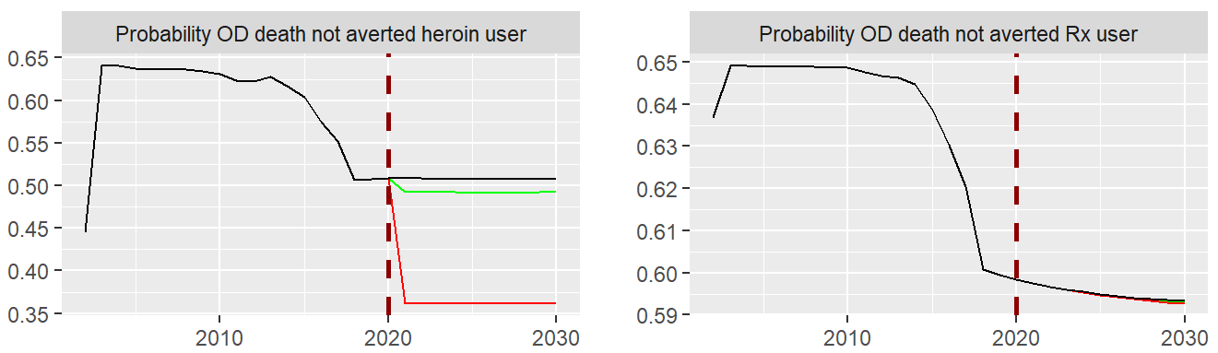

Figure 7‑6: Result of Increasing Probability Nx bystander heroin (ID 5) on Probability OD death not averted heroin and Probability OD death not averted Rx user

Note: *x-axis = year; y-axis = probability. The vertical line designates the scenario start year. The colored lines represent different input values (here,* ***Probability Nx bystander heroin****) during each analysis:* Baseline (22%, black), scenario 1 (25%, green), and scenario 2 (50%, red).

Results from increasing the number of naloxone kits distributed for Rx and heroin users show that the decrease in probability of overdose deaths not averted in heroin users is greater than the probability of overdose deaths not averted in Rx users (-4.65% and -1.36%, respectively, compared to baseline in 2030 for the scenario of increasing naloxone kits distributed by 25% for both Rx and heroin users; see Table 11‑1 in the Appendix). For all scenarios, the effect on increasing the probability of averting overdose deaths was slightly greater when increasing naloxone kits distributed for both Rx and heroin users compared to only increasing the number of naloxone kits distributed among Rx users. These findings are qualitatively similar to those of Irvine and Green, who used state-level granularity in their model (compared to national-level granularity in the FDA model).

Increasing naloxone availability (e.g., increasing number of Nx kits distributed) results in reductions in the number of overdoses deaths in people with heroin use disorder (HUD) and in people with Rx OUD. However, the amount of reduction compared to the baseline is around twice as high for people with HUD rather than Rx OUD (-3.91% and -1.70%, respectively, compared to the baseline in 2030 for scenario of increasing naloxone kits distributed by25% for both Rx and heroin users). These findings are qualitatively consistent with the findings in Pitt (2018).

### 7.5.2 Treatment Expansion

For treatment expansion policy, we tested different interventions including increasing the average duration of treatment, increasing treatment seeking rates, and increasing treatment capacity for all three treatment medications (i.e., Bup, MMT, and Viv). Testing the first two interventions involved changing only one policy lever, while the third required changing three policy levers simultaneously. For each intervention, we tested different scenarios. The detail for the setup of each policy along with samples of the policy questions that can be answered through each test is provided in Table 7‑2. Informal, supplemental results, including graph-over-time plots for all the policies and scenarios in Table 7‑2, can be found in the [GeneratingScenario.zip](http://sharepoint.fda.gov/orgs/CDER-OPSA/PEIS/opioidspolicytool/Shared%20Documents/Opioids%20Policy%20Tool/D06ab%20-%20Initial%20Validation%20Report%20+%20Final%20Validation%20Report/GeneratingScenario.zip) file.

Table 7‑2: Policy Interventions Tested for Treatment Expansion

|  |  |  |  |  |  |
| --- | --- | --- | --- | --- | --- |
| ID | Policy Category | Policy Question | Input | Changes to the Input (2020-2030) | Baseline Value |
| 7 | Expansion of medication for opioid use disorder (MOUD) treatment | What if the average length of time individuals stay on MOUD increased? | **Tx average duration net** | Increase by: 20%, 40%, 50% | Bup: 0.65 (year)  MMT: 0.91  Viv: 0.31 |
| 8 | Expansion of MOUD treatment | What if treatment-seeking increased? What if patients are referred to MOUD Tx after emergency department (ED) overdose rescue? | **Tx seeking rate Rx OUD no H total net** | Increase to the following values: 0.55, 0.65, 0.75 (1/year) | 0.49 (1/year) |
| 9 | Expansion of MOUD treatment | What if treatment capacity for people with use disorder increased? What if the prescribing waiver policy changed?  What if pharmacists could prescribe medication for OUD? | **Bup total theoretical capacity MMT capacity estimated Viv capacity estimated** | Increase by: 10%, 20%, 50% | Bup: 3,540,000 (people)  MMT: 456,488  Viv: 34,825.7 |

One of the interventions that we tested was increasing treatment capacity for all three treatment methods (i.e., Bup, MMT, and Viv). Increasing treatment capacity by 20% reduces **Total nonfatal overdoses** and **Total overdose deaths,** though the full effect size of the intervention is only apparent after 4 years of implementation. Although increasing treatment capacity increases the number of people with Rx OUD (**Rx OUD all total**), the number of people with HUD (**HUD total**) decreases, and there is a net 0.44% decrease in **Total with UD** compared to baseline at the end of the simulation in 2030 (see Figure 7‑7). The 20% increase in treatment capacity also results in a reduction in total overdoses (1.67% decrease in **Total nonfatal overdoses** and 2.90% decrease in **Total** **overdose deaths**)by 2030, reflecting reduced frequency of use and reduced exposure to fentanyl. Increasing treatment seeking rate up to 65% results in similar outcomes.

One point of departure of the current model compared to the HWM is related to the impact of treatment expansion on the number of people with heroin OUD. Homer and Wakeland (2020) found that "boost in MAT reduces persons with heroin OUD". However, in model v1110, increasing treatment capacity increases **Rx OUD with PY heroin total** by 0.91%, and increasing treatment seeking rate increases **Rx OUD with PY heroin total** by 3.05%.

Figure 7‑7: Results of Increasing the Treatment Capacity (ID 9) by 20%

By increasing treatment capacities of all three treatments, the number of people with HUD in **MOUD Tx[MMT]** and **HUD in MOUD Tx[Viv]** both increase, but the number of people with **HUD in MOUD Tx[Bup]** decreases. The model assumption is that the treatment seeking fraction for Bup is higher than MMT and Viv, so decreases in the number of people with **HUD in MOUD Tx [Bup]** in all three scenarios were surprising (See Figure 7‑8). One possible explanation for the lack of increase in people with **HUD in MOUD Tx [Bup]** is the rapid increase in Bup capacity before 2020. This increase means that Bup is no longer capacity limited after 2020, and thus, increasing capacity after 2020 is not an effective way to increase the number of people in treatment. In other words, this explanation would suggest that for Bup, the barrier for seeking treatment is not capacity related, and there could be other barriers associated with Bup, such as insurance coverage. However, this reasoning still does not account for the substantial decrease of people in Bup treatment. To explore this phenomenon, we separately increased the capacity for MMT and Viv by 20% to check the impact on people in Bup treatment. We found that increasing MMT capacity alone increases **HUD in MOUD Tx[MMT]** and reduces **HUD in MOUD Tx [Bup]** (see Figure 7‑9), while increasing Viv capacity does not change HUD in MOUD Tx for Bup (see Figure 7‑10). These findings result in part from the model’s assumptions about the therapy-seeking rates of the three treatment paths. The choice of which therapy to seek is not influenced by relative availability. There is no feedback from capacity utilization that affects people’s decision for seeking one treatment versus another. In other words, if a person seeks one therapy and cannot get it, they will not seek another method.

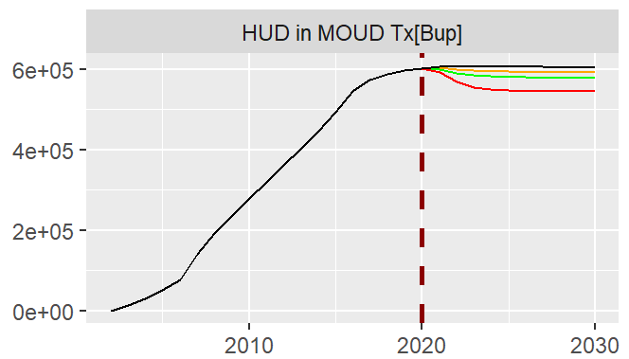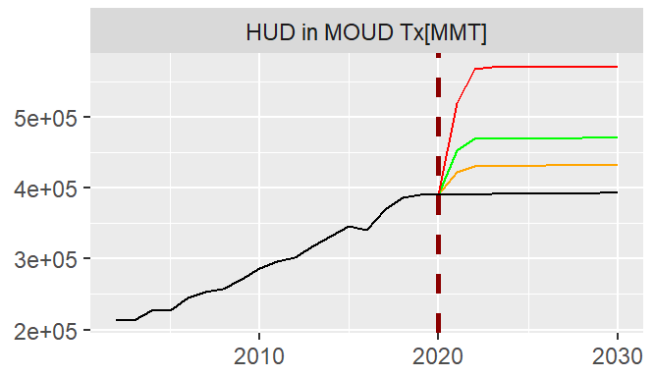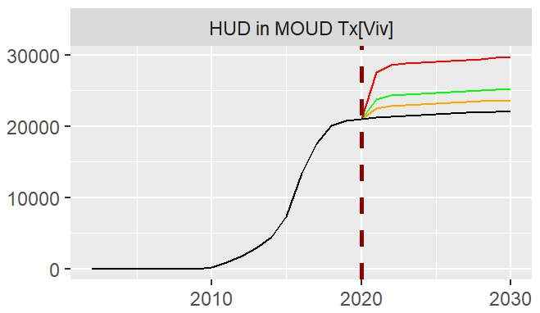

Figure 7‑8: Number of People with HUD in MOUD Tx for Bup, MMT, and Viv for Different Increases in Treatment Capacities (ID 9).

*Note: x-axis = year; y-axis = number of people. The vertical line designates the scenario start year. The colored lines represent percentage increase in the input values (here inputs are* ***Bup total theoretical capacity, MMT capacity estimated, and Viv capacity estimated****) during each analysis: baseline (black), scenario 1 (+10%; orange), scenario 2 (+20%, green), and scenario 3 (+50%, red).*

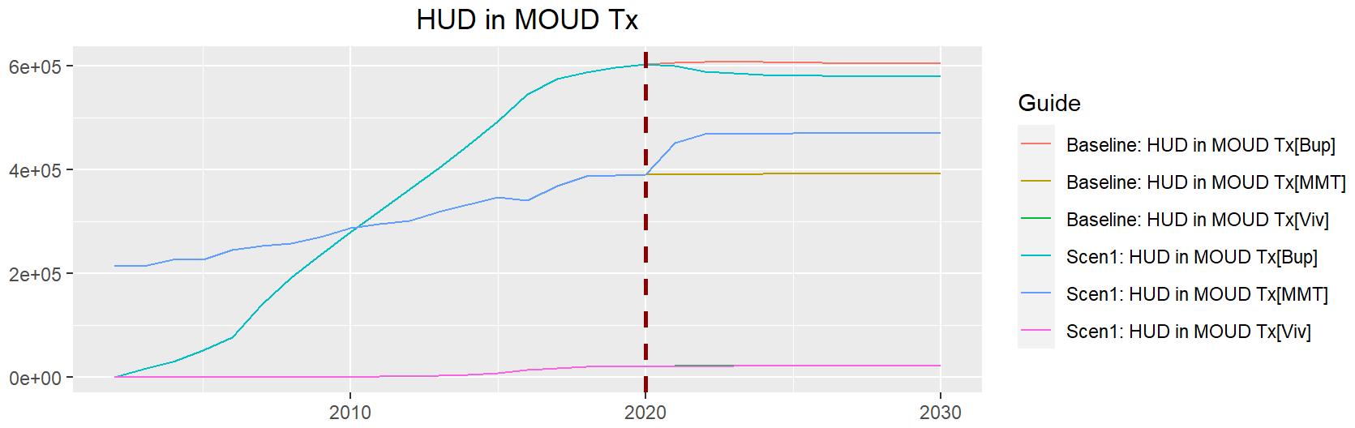

Figure 7‑9: Number of People with HUD in MOUD Tx for Bup, MMT, and Viv for the Scenario Only Increasing MMT Capacity by 20%

*Note: x-axis = year; y-axis = number of people. The vertical line designates the scenario start year.*

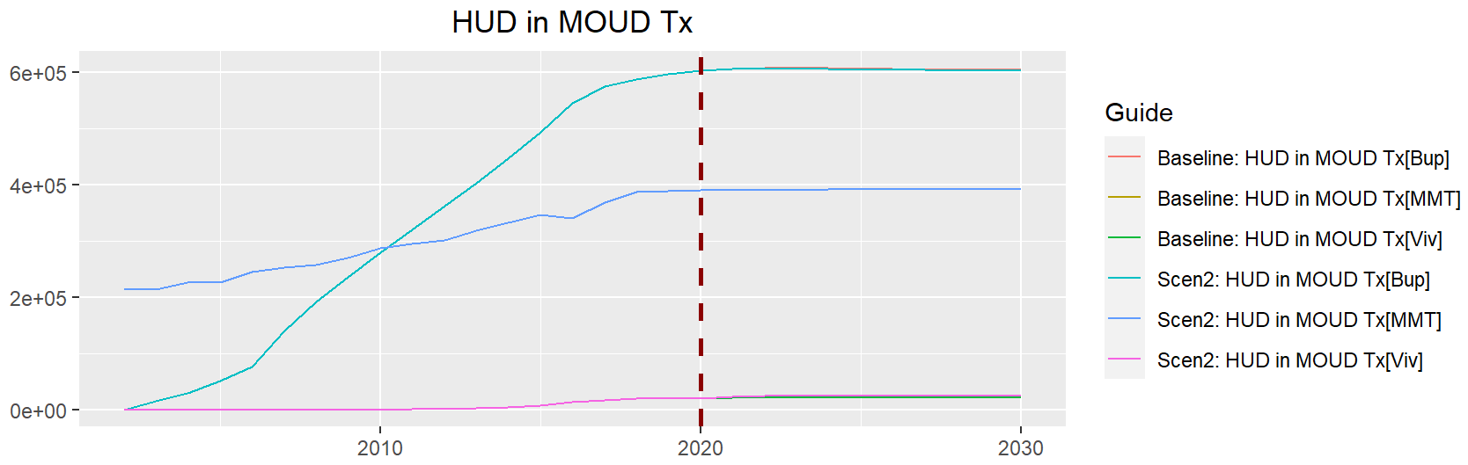

Figure 7‑10: Number of People with HUD in MOUD Tx for Bup, MMT, and Viv for the Scenario Only Increasing Viv Capacity by 20%

*Note: x-axis = year; y-axis = number of people. The vertical line designates the scenario start year.*

Model v110 assumes that there is a relationship between duration of the treatment and effectiveness of the treatment. To test this relationship, we increased the treatment duration by 20%, 40%, and 50%, and in all scenarios, there was a decrease in **HUD total** andan increase in **HUD in remission,** but there was also a minor increase in **Rx OUD no PY heroin total** after 2025. The overall result of the intervention was to decrease the **Total with UD** (see Figure 7‑11).

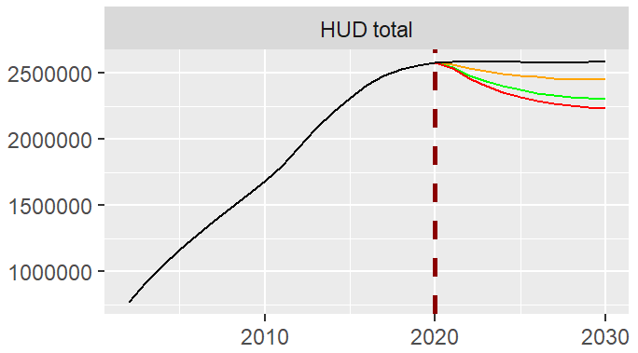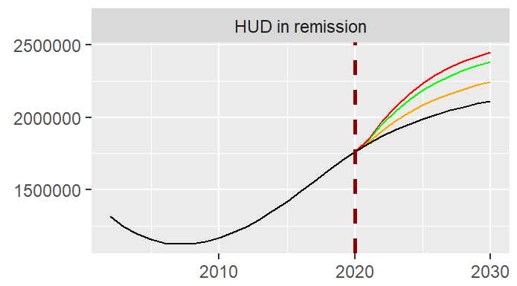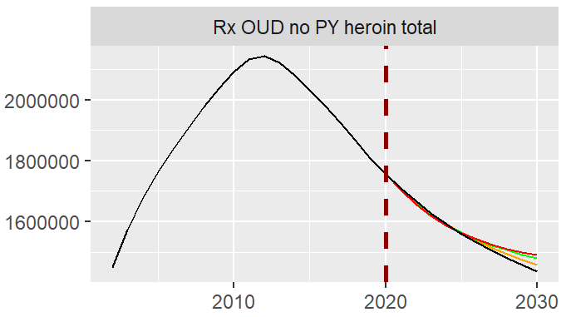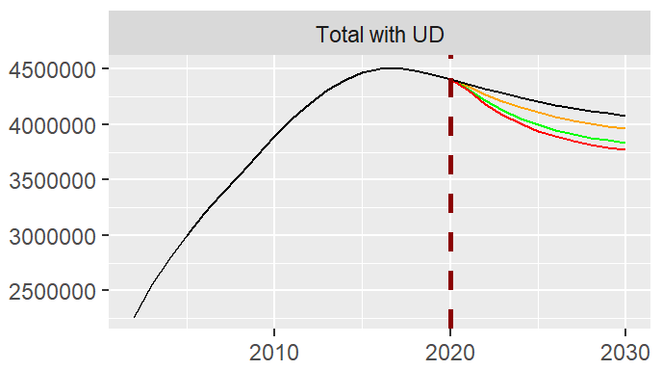

Figure 7‑11: Results of Increasing the Duration of the Treatments on Different Output Variables (ID 7)

*Note: x-axes = year; y-axes = number of people. The vertical line designates the scenario start year. The colored lines represent percentage increase in the input values (here,* ***Tx average duration net****) during each analysis: Baseline (black line), scenario 1 (+20%, orange), scenario 2 (+40%, green), and scenario 3 (+50%, red).*

Treatment expansion (e.g., increasing treatment seeking rate) results in a reduction in the number of overdose deaths compared to baseline in people with HUD and in people with Rx OUD. However, the decrease is greater for people with HUD than for people with Rx OUD (e.g., -10.18% and -1.50%, respectively, compared to the baseline in 2030 for the scenario of setting treatment seeking rate to 0.65; see Table 11‑2 in the Appendix). These findings are qualitatively consistent with the findings in Pitt’s paper.

### 7.5.3 Combination of Increasing Nx Availability and Treatment Expansion Policies

We explored the combined implementation of interventions involving both increasing naloxone availability (i.e., probability naloxone bystander and naloxone kits distributed) and treatment expansion (i.e., treatment capacity, treatment seeking rate, and treatment duration). Each policy involved adjusting at least three policy levers, and in each case, we tested different scenarios. The details of inputs for each policy and lists of scenarios are provided in Table 7‑3. Informal, supplemental results, including graph-over-time plots for all the policies and scenarios in Table 7‑3, can be found in the [GeneratingScenario.zip](http://sharepoint.fda.gov/orgs/CDER-OPSA/PEIS/opioidspolicytool/Shared%20Documents/Opioids%20Policy%20Tool/D06ab%20-%20Initial%20Validation%20Report%20+%20Final%20Validation%20Report/GeneratingScenario.zip) file.

Table 7‑3: Policy Interventions Tested for Combination of Increasing Naloxone Availability and Treatment Expansion

|  |  |  |  |  |
| --- | --- | --- | --- | --- |
| ID | Policy Category | Input | Baseline Value | Changes to the Input |
| 10 | Increasing Nx availability & Tx expansion | **Probability Nx bystander Rx** | 4.7% | Scenario 1: 20%, no change, +20%  Scenario 2: 25%, 25%, +20% Scenario 3: 50%, 50%, +50% |
| **Probability Nx bystander heroin** | 22% |
| **Tx average duration net** | Bup: 0.65 (year)  MMT: 0.91  Viv: 0.31 |
| 11 | Increasing Nx availability & Tx expansion | **Probability Nx bystander Rx** | 4.7% | Scenario 1: 20%, no change, 0.65 Scenario 2: 25%, 25%, 0.65 Scenario 3: 50%, 50%, 0.65 |
| **Tx seeking rate Rx OUD no H** | 22% |
| **Tx seeking rate Rx OUD no H total net** | 0.49 |
| 12 | Increasing Nx availability & Tx expansion | **Nx kits distributed Rx user net** | 296,785 | Scenario 1: +20%, no change, 0.65 Scenario 2: +25%, +25%, 0.65 Scenario 3: +20%, +25%, 0.75 Scenario 4: +50%, +50%, 0.65 |
| **Nx kits distributed H user net** | 1.823 M |
| **Tx seeking rate Rx OUD no H total net** | 0.49 |
| 13 | Increasing Nx availability & Tx expansion | **Probability Nx bystander Rx** | 4.7% | Scenario 1: 20%, no change, all three +20% Scenario 2: 20%, no change, all three +50% Scenario 3: 50%, 50%, all three +50% |
| **Probability Nx bystander heroin** | 22% |
| **Bup total theoretical capacity MMT capacity estimated Viv capacity estimated** | Bup: 3.54 M (people)  MMT: 456,488  Viv: 34,825.7 |

One of the imagined policies that we evaluated was a combination of increasing naloxone availability and expanding treatment through increasing **Probability Nx bystander Rx** and **Probability Nx bystander heroin** while also increasing treatment capacity for Bup, MMT, and Viv. For Scenario 1, where only **Probability Nx bystander Rx** increases, the combined interventions reduce **Total overdose deaths** by 5.27% and overdoses by 1.27% compared to baseline in 2030 (see Figure 7‑12). These results reveal that a combination of these policies can better reduce number of overdose deaths compared to individual policies. Combining these two policies (i.e., increasing naloxone availability and expanding treatment) increased **Total heroin initiation** by 0.87%, while individually increasing probability of Nx bystander Rx to 20% and increasing Tx capacity by 20% increased **Total heroin initiation** by 0.49% and 0.37%, respectively.

Figure 7‑12: Results of Increasing Probability of Nx Bystander for Rx Users to 20% and Increasing Treatment Capacity by 20% (ID 13, Scenario 1)

Considering the three scenarios for the interventions of increased Tx capacity and increased Probability Nx bystander leads to an interesting result. When increasing the Tx capacity and the **Probability Nx bystander Rx** without increasing **Probability Nx bystander heroin** (scenarios 1 and 2 in Figure 7‑13), the number of people with HUD (**HUD total**) decreases compared to the baseline. This effect occurs because more people with HUD are treated. However, increasing Tx capacity and both **Probability Nx bystander Rx** and **Probability Nx bystander heroin** results in an increase in the number of people with HUD compared to the baseline; after introducing increased Nx bystander heroin to the system, the change in number of people who develop HUD is greater than the change in number of people with HUD who are being treated. One reason for this behavior is that increasing **Probability Nx bystander heroin** reduces **Overdose death HUD**, therefore, more people with HUD live, resulting in a greater number of HUDs. Paradoxically, better therapy leads to an increase in the prevalence of HUDs, precisely because they do not die (see Figure 7‑13).

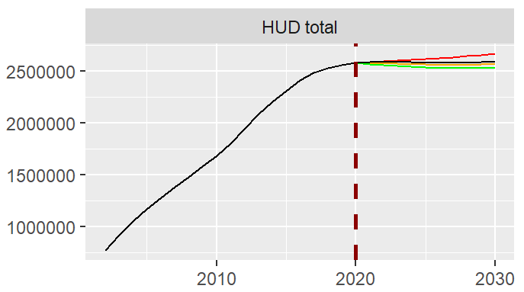

Figure 7‑13: Number of People with HUD when Increasing Tx Capacity and Probability Nx Bystander (ID 13)

*Note: x-axis = year; y-axis = number of people. The vertical line designates the scenario start year. The colored lines represent percentage increase in the input values during each analysis (inputs in this test are* ***Probability Nx bystander Rx, Probability Nx bystander heroin, Bup total theoretical capacity, MMT capacity estimated****, and* ***Viv capacity estimated****): The black line represents the Baseline, Scenario 1 (20%, no change, all three +20%, orange), Scenario 2 (20%, no change, all three +50%, green), and Scenario 3 (50%, 50%, all three +50%, red).*

Another scenario that we tested was a combination of increasing naloxone availability and expanding treatment is increasing **Probability Nx bystander Rx** to 20% and increasing treatment seeking rates for Bup, MMT, and Viv to 0.65. Combining these two interventions has a greater impact on reducing **Total overdose deaths** and **Probability OD death not averted heroin use** (see Figure 7‑14) compared to the intervention of increasing Tx capacity instead of Tx seeking rate (see Figure 7‑12). These results suggest that addressing the barriers for people to seek treatment (e.g., insurance coverage) may have greater impact than increasing treatment capacity.

Figure 7‑14: Results of Increasing Probability of Nx bystander for Rx users to 20% and Increasing Treatment Seeking Rate to 0.65 (ID 11, Scenario 1)

We also compared different scenarios for increasing treatment seeking and probability naloxone bystander. When Tx seeking rate is increased to 0.65, increasing Nx availability for both Rx and heroin bystanders to 50% increases the total number of people with HUD relative to baseline over time, with a 2.04% increase in **HUD total** by 2030 (scenario 3; Figure 7‑15, right graph, red line). An explanation for this behavior is that increasing Nx availability reduces overdose deaths, which lowers perceived risk of heroin. Lower perceived risk leads to an increase in heroin initiation (e.g., **Initiating heroin with Rx misuse,** **Initiating heroin with Rx OUD**, and **Initiating heroin no Rx**) and ultimately increases the number of people with HUD over time. This increase in the number of people with HUD also has effects on the number of people in treatment. Comparing scenarios 2 and 3, where Nx availability to bystanders is increased to 25% and 50%, respectively, there is a decrease in **HUD not in MOUD Tx** by 8.43% and 4.98%, respectively, compared to baseline in 2030 (see Figure 7‑15, left graph).

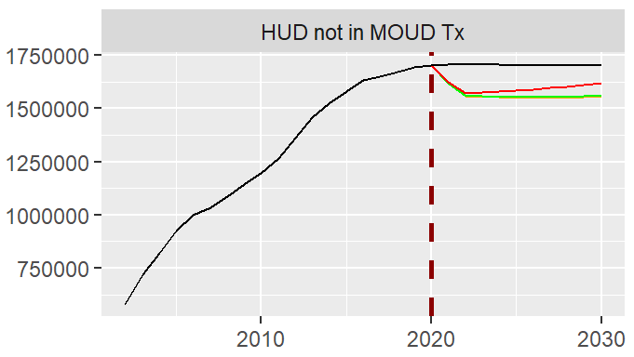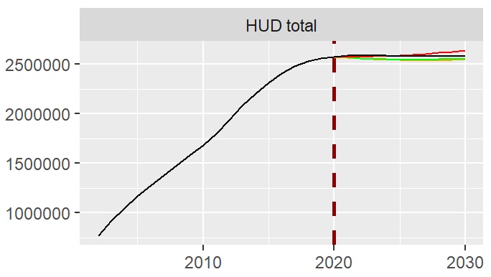

Figure 7‑15: Number of People with HUD not in MOUD Tx and HUD total When Increasing Tx Seeking Rate and Probability Nx Availability Bystander (ID 11)

*Note: x-axes = year; y-axes = number of people. The vertical line designates the scenario start year. The colored lines represent percentage increase in the input values during each analysis (inputs in this test are* ***Probability Nx bystander Rx, Probability Nx bystander heroin,*** *and* ***Tx seeking rate Rx OUD no H total net****): The black line represents the Baseline, Scenario 1 (20%, no change, 0.65, orange), Scenario 2 (25%, 25%, 0.65, green), and Scenario 3 (50%, 50%, 0.65, red).*

When combining the interventions increasing naloxone availability to bystanders and increasing treatment seeking rate (ID 11), we also found interesting results for the number of OD deaths of people with HUD in Bup treatment. Each scenario increased treatment seeking rate to 0.65. Increasing naloxone availability to bystanders up to either 20% or 25% (scenarios 1 and 2 in Figure 7‑16) increases the number of OD deaths of people with HUD in Bup treatment compared to the baseline, but increasing naloxone availability to 50% decreases the number of overdose deaths compared to the baseline (scenario 3 in Figure 7‑16).

Examining the equation for **Overdose death HUD in MOUD Tx** shows it is equal to **HUD in MOUD Tx** * **OD death rate HUD in MOUD Tx**. Since the amount of increase in **HUD in MOUD Tx** is larger than the decrease in **OD death rate HUD in MOUD Tx** for the first two scenarios, there is an increase in the number of OD deaths for people with HUD in Tx via Bup compared to the baseline. Compared to the first two scenarios, the third scenario results in a greater reduction in **OD death rate HUD in MOUD Tx[Bup]** compared to the baseline, and this results in a decrease in number of overdose deaths compared to the baseline in the third scenario. To elaborate, the effect of these combined interventions shows that increasing probability of bystander naloxone availability up to 50% and seeking Tx up to 0.65 (scenario 3 in Figure 7‑16) can decrease **OD death rate HUD in MOUD Tx** more than it increases the number of **HUD in MOUD Tx**. That is, increasing the probability of Nx bystander heroin affects overdose death rate HUD, which affects **OD death rate HUD in MOUD Tx**. This supports the behavior in Figure 7‑16.

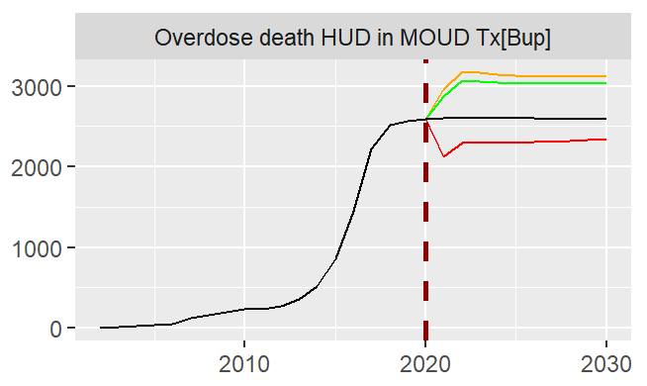

Figure 7‑16: Number of Overdose death HUD in MOUD Tx[Bup] When Increasing Tx Seeking Rate and Probability Nx Availability Bystander (ID 11)

*Note: x-axis = year; y-axis = number of people. The vertical line designates the scenario start year. The colored lines represent percentage increase in the input values during each analysis (inputs in this test are* ***Probability Nx bystander Rx, Probability Nx bystander heroin****, and* ***Tx seeking rate Rx OUD no H total net****): The black line represents the Baseline, Scenario 1 (20%, no change, 0.65, orange), Scenario 2 (25%, 25%, 0.65, green), and Scenario 3 (50%, 50%, 0.65, red).*

We discovered a similar type of effect on overdose deaths in Bup treatment for Rx OUD without heroin. When we increase naloxone availability to 20%, 25%, and 50% combined with increasing treatment seeking rate to 0.65 (ID 11), scenarios 1 and 2 result in more overdose deaths (i.e., **Overdose death Rx OUD no H in Tx[Bup]**) compared to the baseline (after 2022), but scenario 3 results in fewer overdose deaths compared to the baseline starting from 2020 (see Figure 7‑17). By exploring the model, we realized that in the first two scenarios, the reason for this result is that the increase in **Rx OUD no heroin in MOUD Tx** is larger than the decrease in **OD death rate OUD no H in Tx**. However, in the third scenario, there is a greater reduction in **OD death rate OUD no H in Tx** compared to the first two scenarios, and this causes there to be an overall decrease in the number of overdose deaths for the third scenario. The effect of these combined interventions shows that increasing probability of naloxone bystander availability up to 50% and seeking treatment up to 0.65 (scenario 3) can decrease **OD death rate OUD no H in Tx** more than the increase the **Rx OUD no heroin in MOUD Tx**.

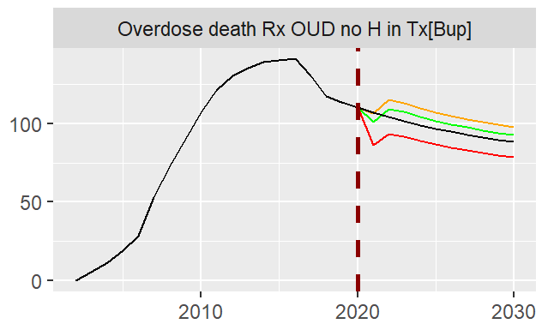

Figure 7‑17: Number of Overdose death Rx OUD no H in Tx[Bup] When Increasing Tx Seeking Rate and Nx Availability Bystander (ID 11)

*Note: x-axis = year; y-axis = number of people. The vertical line designates the scenario start year. The colored lines represent percentage increase in the input values during each analysis (inputs in this test are* ***Probability Nx bystander Rx, Probability Nx bystander heroin****, and* ***Tx seeking rate Rx OUD no H total net****): The black line represents the Baseline, Scenario 1 (20%, no change, 0.65, orange), Scenario 2 (25%, 25%, 0.65, green), and Scenario 3 (50%, 50%, 0.65, red).*

More results, including graph over time plots for different interventions and scenarios individually or combined together are included in Figure 11‑1 and Table 11‑3 in the Appendix.

# Model Comparator

In this section, we present a comparison of model v1110 with the published, peer-reviewed HWM. We also report on a comparison of two policy scenarios analyzed in model v1110 and using the HWM.

## Comparison with Homer and Wakeland 2020

This sub-section reports on a comparison of model v1110 with a model we call here the HWM. Several characteristics of the HWM make it an ideal choice for model comparison. First, both model v1110 and the HWM are models about opioids at the U.S. national level using system dynamics simulation methodology. Not only are they both system dynamics models, but they are also both built in the same simulation software (i.e., Vensim). Second, a journal article based on the HWM has been published in peer-reviewed scientific literature, which is evidence that the model has been subject to scrutiny by qualified journal reviewers and editors (Homer and Wakeland 2020). The published article offers complete scientific documentation of the HWM, including a complete listing of all model equations and parameter values, and such transparency facilitates a useful comparison with the focal model v1110. Third, the purposes of the two models are similar in that the primary aim of both models is to evaluate a range of policy interventions and allow examination and perhaps quantification of the intended and unintended consequences of the policy interventions tested.

The following compares model v1110 with the HWM. Table 8‑1 provides a summary of a comparison of the model structures of the two models across a select set of model characteristics. In brief, model v1110 compares favorably with the HWM. Model v1110 is a larger, more nuanced model with additional stocks and flows and additional feedback structure. It is constructed using standard, well-understood system dynamics formulations. That is, the building blocks are sound, and the construction is conceptually clear. As such, model v1110 structure is consistent with and has additional important and useful details and complexity compared to the HWM.

Table 8‑1: Model Comparison Between Model v1110 and the HWM

|  |  |  |
| --- | --- | --- |
| User Stocks | Homer and Wakeland (2020)[2] | Model v1110 |
| Casual NMUs of POs with no heroin use | Casual PONHA | Rx misuse no PY heroin |
| OUD users of POs with no heroin use | Addicted PONHA | Rx OUD no PY heroin not in MOUD Tx |
| Rx OUD no heroin in MOUD Tx |
| Rx OUD no heroin in remission |
| OUD users of POs with heroin use | Casual HPPOU | Rx OUD with PY heroin not in MOUD Tx |
| Rx OUD with heroin in MOUD Tx |
| Rx OUD with heroin in remission |
| Other Heroin Users | Casual HNPOU | Non-disordered heroin use |
| Addicted HNPOU | HUD not in MOUD Tx |
| Addicted HPPOU | HUD in MOUD Tx |
|  | HUD in remission |
| **Supply Stocks** | **Supply Stocks** |
| Disguised Fent pills supply | Rx street supply disruption |
| Street supply authentic | Tx exposure |
| **Outcomes** | **Outcomes** |
| Cumul opioid OD deaths | Cumulative nonfatal overdoses since 2002 |
| Cumul opioid ODs reversed by laypersons start 1996 | Cumulative overdose deaths since 2002 |
| Cumul opioid overdoses |  |
| Cumul script gms ME |  |
| Sources of initiation | Own Rx, Diverted Rx | Own Rx, Diverted Rx |
| Relapsing after 1-year abstinence | Implicit, as re-initiation | Explicit stocks for in remission and flows for relapsing |
| Core Feedback Structure | | |
| Social Influence based on: | Not included | "Contagion:" Users as fraction of population |
| Social Influence effects on: | Initiating flows | Initiating, Escalating flows |
| Risk Perception based on: | Overdoses | OD deaths and non-fatal ODs |
| Risk Perception effects on: | Initiating flows, Quitting flows | Initiating flows, Quitting flows |
| Street Supply based on: | Endogenous diversion fraction, Prescriptions and MMEs/prescription | Prescriptions and MMEs/prescription |
| Street Supply effects on: | Initiation, Escalation, Addiction, Quitting Flows | Initiating and quitting misuse, escalating to OUD |
| Heroin Price based on | Exogenous time series of heroin price | Exogenous time series of heroin price |
| Heroin Price effects on: | Escalating to heroin | Initiating and quitting heroin, escalating to HUD, |
| Rx vs Heroin price based on: | Exogenous series of heroin price per mg | Endogenous Rx price compared to exogenous heroin price |
| Rx vs Heroin price effects on: | Escalating to heroin | Initiating heroin with Rx OUD, initiating NDHU with Rx, developing HUD with Rx OUD |
| MAT based on: | Exogenous time series of treatments | Endogenous flows from user stocks, explicit treatment capacities |
| MAT Effect on: | Quitting, Freq of use, Risk of OD | Entering remission, Exiting treatment to OUD |
| Supply of Opioids | | |
| Medical users modeled based on PO scripts | Yes | Yes |
| PO Scripts based on exogenous time series | Yes | Yes |
| Aggregates opioids to MME | Yes | Yes |
| Average dose strength | Exogenous time series | Exogenous time series |
| Supply on street | All PO on street, Fent on street | Calculated from several exogenous time series |
| Relative availability | Ratio of combined stock to demand | Ratio of calculated supply to demand |
| Feedback from availability/price of POs | On diversion (supply), On demand | No |
| Disruptions/interventions | Diversion control reduces flow of new supply | Temporary disruptions modeled as stock and does not match documented magnitude |
| Tamper-resistant pills | Implicit, as supply disruption | Explicit representation of ADFs |
| Overdoses and Deaths | | |
| Non-oral risk of OD | Explicit and separate, Relative to risk for oral user | Not explicit |
| Risk modification for fentanyl | Pills endogenous, powder exogenous | Fentanyl penetration in heroin influences ODs and deaths |
| Naloxone | Aggregated | Explicitly models LEO, EMS, and bystander use of Nx |
| Overdoses calculated from deaths | Yes | No, ODs and deaths calculated explicitly from user stocks |
| Heroin | | |
| Routes of initiation to heroin | From prior PO NMU and not | From prior PO NMU and not |
| Heroin price | Exogenous time series | Exogenous time series |
| Routes of developing HUD | From prior PO OUD, Escalation from non-OUD heroin | From prior PO OUD, Escalation from non-OUD heroin |

### Core Model Logic and Structure

Two key elements are the core of any system dynamics model. The first is the stock and flow structure, and the second is the set of interacting feedbacks that govern the rates of change of the stocks. At a high level, the two models are quite similar. Both disaggregate the population of opioid users and abusers in the U.S. into a set of stocks that are connected by a series of flows that represent the entry to or exit from these stocks, or categories of users. Both include flows such as initiating use or abuse, escalating or transitioning between categories, quitting, and dying from opioid overdoses or from other causes. Both also include dozens of feedback loops, and we will focus our comparison below on the conceptually most important of these feedbacks.

The HWM subdivides the population of non-medical users (NMU) of opioids into six mutually exclusive stocks that are defined by two criteria. One criterion is the type of drugs used in a given year, resulting in three categories: NMUs who use prescription opioids (PO) but not heroin, NMUs who use POs and also use heroin, and those who use heroin but not POs. Within each of these categories, they have two stocks, one for casual users and the other for addicts, defined as those with OUD, for a total of six stocks of users.

Model v1110 subdivides the population of NMUs of opioids into 11 mutually exclusive stocks. In contrast to the HWM which represents disease progression in only two categories (casual and addict), model v1110 disaggregates progression into stages that include PO misusers who do not use heroin, PO users with OUD who do not use heroin, PO users with OUD who do use heroin, and then those with HUD. In addition to these five categories of PO misusers, model v1110 includes a stock of non-disordered heroin users. Model v1110 assumes that some fraction of heroin users in both the stocks for HUD and for non-disordered use are also users of POs, but model v1110 does not include explicit stocks that match those in the HWM for heroin users.

Model v1110 also subdivides the three central categories of disordered users into those who are not in medication-assisted therapy (MAT), those who are currently in MAT, and those in remission. Thus, there are three sub-categories each for PO users with OUD who do not use heroin, PO users with OUD who do use heroin, and those with HUD for a total of nine stocks in these categories. The two stocks for non-disordered use (one for POs and one for heroin) round out the 11 user stocks.

The more disaggregated stock and flow structure found in model v1110 has two main advantages:

* First, the explicit representation of stocks of users in MAT provides a useful foundation for exploring policy interventions related to treatment. The three stocks for users in MAT are each further subdivided into stocks for three kinds of treatment (i.e., Bup, MMT, Viv), so in fact there are nine stocks tracking users in treatment.
* Second, model v1110 includes stocks for disordered users who are in remission. This is consistent with a belief that an opioid disorder is never cured, and the model allows for explicit representation of the process of relapse, which generates a flow of people from a stock of persons in remission back into a stock of users. Such flows might become particularly important as the numbers of persons in remission grow – which we would expect to happen over time due to continuous accumulation of those who have gone into remission and also due to possible future expansions in treatment that successfully transitions more users into remission.

Neither model includes an explicit stock to represent people with opioid prescriptions, but instead both models determine the flows of initiating PO misuse as comprising flows from patients with opioid prescription who begin misuse and also from people who acquire POs that are diverted to “street supply.” Estimates of the magnitudes of these flows are driven by time series data streams in both cases.

### Key Conceptual Feedback Structure

Model v1110 includes three major sets of feedback loops that influence the behavior of opioid users regarding the rates of initiating misuse, escalating to more severe categories (e.g., to OUD, to heroin use, or. to HUD), seeking treatment, and quitting. One set of loops includes those that capture the effects of availability and price of POs and the price of POs relative to heroin. Generally, lower prices and greater availability cause increases in initiating and escalating and decreases in quitting. Increases in the price of POs relative to the price of heroin increase the likelihood of heroin use, as a less expensive alternative. A second set of feedback loops models risk perception or fear. Thus, increases in overdoses and/or deaths from overdoses lead to reductions in initiating and to increases in quitting. Although there are some differences in the operationalization of these feedback loops, both model v1110 and the HWM model include these feedback effects, as shown in Table 8‑1.

A third set of feedback loops models the effects of social influence on the flows for initiating and escalating to more severe categories. More users and more advanced users both increase the likelihood that others will be exposed to and possibly influenced by the users, so this social influence creates a reinforcing feedback loop in which more users beget even more users. The operational character of such feedback is similar to the contagious spread of a disease, and model v1110 models this effect using a well-established approach. The Homer and Wakeland (2020) paper labels social diffusion in their model overview, and the HWM includes similar feedback from stocks of users to their inflows. The explicit and separate representation of these feedbacks in model v1110 model allows for a more fine-grained choice of parameters, enabling the adjustment of the effect sizes in a more nuanced manner.

Both models recognize the importance of heroin price. In particular, when heroin prices are low relative to street prices for POs, PO users are more likely to escalate to heroin, driven by the less expensive alternative. Both models use exogenous time series for heroin prices. Both models include effects of heroin price on flows modeling escalation to heroin. Model v1110 also includes heroin price influences on flows for initiating and quitting as well as developing HUD with Rx OUD. Thus, model v1110 includes a more complex set of feedback effects of heroin price on the various flows in the stock and flow chains.

### Treatment

The two models differ in the way they model MAT for opioids. Model v1110 includes a more explicit and more detailed representation of MAT, so this is an area in which model v1110 has additional important and useful details and complexity compared to the HWM. As mentioned previously, model v1110 explicitly tracks users who are in therapy according to three types of MAT: buprenorphine, methadone, and vivitrol. Along with the explicit stocks for these users, model v1110 also includes explicit representation of users seeking treatment, users entering treatment, users successfully completing treatment, and users leaving treatment before completion. With this more explicit structure, model v1110 is able to include a feedback effect of users in treatment on flows for seeking and initiating treatment, capturing the social influence of and word-of-mouth from patients in treatment. Model v1110 also tracks the users in remission, some of whom accomplished the transition to remission by going through MAT. Model v1110’s stock and flow structure for treatment and more detailed disaggregation by treatment type give the user good visibility and an intuitively appealing description of the dynamics of patients seeking or receiving treatment. Model v1110 also models the supply, or capacity, of MAT for each type, thus enabling a straightforward test of policies related to treatment. The core feedback construct in both models is similar: treatment leads to a lower likelihood of death from overdose and to a higher likelihood of quitting. The HWM specifically represents an effect of treatment on frequency of use of opioids by various user categories, which in turn influences the fractional death rates. Instead, model v1110 generates a similar effect of treatment by modeling separate flows of deaths from patients in treatment and from users not in treatment. Similarly, model v1110 captures the effect of treatment on frequency of use by assuming a different average consumption for those in treatment versus those who are not.

### Opioid Supply

The models differ slightly in the way in which they model the supply of POs available on the street. Both models follow established approaches in the system dynamics tradition. The key idea behind both models is that some fraction of legitimate opioid prescriptions are diverted to be available for NMUs’ consumption. In addition, counterfeit or illicit opioids (e.g., fentanyl) also enter the street supply. Both models estimate PO street availability starting from exogenous time series of opioid prescriptions and use milligram morphine equivalents (MME) to aggregate across various drugs, which is a useful simplification. Street supply is impacted by diversion control attempts (e.g., by the DEA). Both models explicitly include an exogenous effect of DEA intervention actions to reduce diversions from 2010 to 2013. The HWM models the effect of these interventions straightforwardly as a fractional reduction in the street supply that affects the flow of newly diverted POs for the duration of the intervention.

Model v1110 does not include a specific stock for supply of POs, so instead model v1110 includes a stock called ”Rx Street Supply Disruption” that accumulates several influences on street supply and dissipates them to mimic the somewhat rapid adjustment of street supply to disruptions. Both the magnitude and dynamics of the effect of the DEA intervention differ in the two models, and we recommend further exploring this difference. Unfortunately, it appears that the behavior of model v1110 model does not match the effects stated in the documentation. Specifically, the embedded comment suggests a diversion reduction of 10% *per year for 3 years* but instead with the baseline model settings the disruption takes *3 years to grow to 12%*. That is, by the end of the first year, disruptions total only 2%, and by the end of the second year only 6%. It is not clear exactly if the pattern of behavior intends to mimic the actual consequences of the DEA intervention, but this does not seem consistent with the pattern described. It is likely that the operationalization of these disruptions needs to be corrected.

### Overdoses, Deaths, and Naloxone

The modeling of non-fatal and fatal overdoses and the effects of naloxone on deaths is considerably more developed in model v1110 compared to the HWM. Each death flow in model v1110 is calculated as a fraction per unit time of the relevant stock of users. The fractional rates depend on the stocks from which they flow and are endogenously modified by other factors such as the prevalence of benzodiazepines in the drug supply, the penetration of fentanyl in the heroin supply, the prevalence of synthetics in the drug supply, and the likelihood that an overdose death is averted due to use of naloxone.

Model v1110 model also contains a well-developed representation of the use of naloxone. Model v1110 carefully accounts for several different causal paths through which an overdosed user might receive naloxone. Model v1110 tracks overdoes through a chain of events that include the likelihood that an overdose is witnessed and if so the likelihood of calling emergency services. Another path is from law enforcement officers (LEO), so the model includes the likelihood of getting naloxone from a LEO (based on an exogenous time series). The model also includes naloxone administration by bystanders, which in turn depends on the availability of naloxone among bystanders, which of course is influenced by naloxone distribution and use policies.

The naloxone sector of model v1110 should be considered a major strength of this model compared to the HWM. The more disaggregated and higher fidelity representation of overdose, naloxone, and deaths will help support a variety of possible policy interventions in this domain. Almost any step in the causal paths described in the previous paragraph offers a possible policy intervention, so the rich detail in this sector will facilitate examination of a range of policy interventions, including combinations using several policy levers.

### Heroin

As shown in Table 8‑1, there is not a one-to-one mapping of the stocks in model v1110 to the stocks in the HWM. There is no reason for concern that the stocks do not map directly to each other, but it does mean that we must be cautious about making comparisons from one model to the other. The difference in stock definitions is most notable in the stocks of heroin users, as shown in the table.

## Policy Comparison

This section reports on a comparison of two policy scenarios analyzed using model v1110 and using the HWM. The Homer and Wakeland (2020) paper reports these scenarios as illustrative tests implemented starting in 2020 through the end of the simulation in 2030. To conduct this policy comparison here, we reproduced the scenarios reported in Homer and Wakeland (2020) and confirmed that the resulting values of three variables in 2030 were as reported in the paper. Homer and Wakeland (2020) selected these three variables for comparison of several policy options because they most directly indicate the burden of opioid use. Accordingly, here we use the same three constructs for comparison of the policy analyses accomplished in the two models (as of 2030): persons with OUD, overdoses, and overdose deaths. The variable names in model v1110 and the HWM are not identical, nor are the exact definitions of these variables, in part due to the differences in stock and flow structure described earlier in Section 8. Table 8‑2 summarizes the results of comparisons of two policy scenarios and includes the exact names of the roughly comparable variables from each of the two models. Persons with OUD and overdose deaths are similar constructs, and the baseline values are similar. However, overdoses are tracked differently in the two models. The HWM reports overdoses seen at the ED, whereas model v1110 instead reports overdoses from POs, some fraction of which would be seen at the ED.

The important comparisons in this section are how the behavior of each model changes relative to its own baseline, not the comparison of variable quantities per se, so we have not attempted to reconcile these differences in baseline values or variable definitions. Such differences are to be expected when models are developed separately. For model v1110, the scenarios reported here are all conducted with the **Switch for Constant Projections** set to 1, which has the effect of holding a set of exogenous time series at their 2020 values, a setting that is somewhat comparable to the baseline runs for the HWM.

Table 8‑2: Policy Comparison Between Model v1110 and the HWM

|  |  |  |  |  |  |  |  |  |  |
| --- | --- | --- | --- | --- | --- | --- | --- | --- | --- |
|  |  | **Homer and Wakeland (2020) Simulated Results as of 2030** | | | | **Percent Change From Baseline** | | | |
|  |  | **Persons with OUD (thou)** | **Overdoses** | | **Overdose deaths** | **Persons with OUD (thou)** | **Overdoses** | | **Overdose deaths** |
| **Scenario**  **or**  **Baseline** | **HW Variable Name** | **Total opioid addicts** | **Overdoses seen at ED** |  | **Total opioid OD deaths** | **Total opioid addicts** | **Overdoses seen at ED** |  | **Total opioid OD deaths** |
| **OSM Variable Name** | **Rx OUD all total** |  | **Total Overdoses Rx** | **Total overdose deaths** | **Rx OUD all total** |  | **Total overdoses Rx** | **Total overdose deaths** |
| **Baseline Measures** | | | | | | | | | |
|  | HWM Baseline | 1,694 | 154,710 |  | 40,323 |  |  |  |  |
|  | Model v1110 Baseline | 1,502 |  | 322,219 | 48,266 |  |  |  |  |
| **Scenario Comparison 1: Avg MME dose down 20%** | | | | | | | | | |
|  | HWM | 1,510 | 152,686 |  | 39,796 | -10.9% | -1.3% |  | -1.3% |
|  | Model v1110 Avg MME dose down 20% | 1,400 |  | 291,932 | 46,762 | -6.8% |  | -9.4% | -3.1% |
| **Scenario Comparison 2: Five-fold increase in Naloxone distribution to laypersons** | | | | | | | | | |
|  | HWM | 1,728 | 159,228 |  | 35,302 | 2.0% | 2.9% |  | -12.5% |
|  | Model v1110 Increase Nx distribution to both Rx and H | 1,482 |  | 318,408 | 37,818 | -1.3% |  | -1.2% | -21.6% |
|  | Model v1110 Increase Nx distribution to only Rx | 1,510 |  | 324,135 | 46,901 | 0.5% |  | 0.6% | -2.8% |

The first scenario we compared is the first scenario reported in Homer and Wakeland (2020). In this scenario, beginning in 2020 the average prescribed opioid dose decreases over a one-year period to 80% of its 2020 value and remains at this reduced value for the duration of the simulation until 2030. As shown in Table 8‑2, the two models exhibit similar responses to this policy intervention. In both models, medical user addiction is reduced (by 10.9% in HWM and 6.8% in OSM). The direction of the effect is the same, and the magnitudes of the effect are similar. Both models show that this intervention reduces availability of POs, and lower availability reduces both initiation of misuse and escalation to PO disorders. Total overdose deaths decrease with both models, although the effect is stronger in model v1110 (-3.1% vs. -1.3% in HWM). Both models show a reduction in overdoses, although as mentioned above the variables for overdoses are not directly comparable. In total, both models show this intervention to be effective in reducing PO addiction, overdoses, and deaths. For this Scenario Comparison 1, the model results are similar.

The second scenario we compared is the fourth scenario reported in Homer and Wakeland (2020). In this scenario, beginning in 2020 the distribution of naloxone to laypersons is expanded five-fold over a one-year period and remains at this higher value for the duration of the simulation until 2030. Note that the two models implement such a policy change differently. The HWM uses an exogenous time series for naloxone distribution, and the 2020 value is 4%. Model v1110 separates naloxone distribution to laypersons into a group for PO users and a group for heroin users. The 2020 values in model v1110 are slightly higher than those in the HWM; so, to facilitate a comparison with each model’s own baseline, we used a five-fold increase from the model’s own 2020 value in both cases. Table 8‑2 shows the results from a five-fold increase in the HWM, from a five-fold increase in distribution to both PO and heroin users in model v1110, and also from a five-fold increase to just the PO users. As shown in Table 8‑2 the two models exhibit similar responses to this policy intervention as well, but they differ more in this scenario that in the first. In both models, one main effect is the reduction of opioid deaths. The reduction in deaths in model v1110 appears to result mostly from a reduction in deaths from heroin, consistent with the fact that overdose deaths among heroin users contribute the largest portion of overdose deaths. Moreover, heroin users are the most exposed to fentanyl concomitants which increases the likelihood of overdosing. In the Homer and Wakeland (2020), this policy intervention is the only one the tested that leads to an increase in the number of overdoses, because some averted overdose death survivors will overdose again. Recall that the variable for overdoses in model v1110 includes a different aggregation of cases. Although a different variable, for the increase in naloxone distribution to PO NMUs only, we also see a small increase in overdoses. For this Scenario Comparison 2, the model results differ somewhat, and the differences are mostly rooted in the more nuanced modeling of overdoses and naloxone use in model v1110.

# Conclusion

Below are the high-level summary of findings from Part 2 of the Final Validation (Section 9.1), recommendations for moving into full operationalization of model v1110 (Section 9.2), and a usability assessment (Section 9.3).

## Summary of Findings

For Final Validation Part 2, the Validation Team evaluated model v1110 to: 1) review and verify updates resulting from Final Validation Part 1 feedback; 2) verify technical documentation is complete and accurate; 3) certify the model adheres to sounds modeling principals; and 4) provide an un-biased evaluation of the model’s readiness to be used in FDA decision-making. The Validation Team previously conducted extensive reviews of model structure, behavior, and documentation (as outlined in the Section 2). The previous reviews have sequentially identified various concerns and action items, and the Grant Team has addressed the majority of these findings. This report identifies minor areas where we recommend improvements (summarized in Section 9.2).

Part 1 of the Final Validation focused on the general behavior and structural assessment of model v831. In this report, Part 2 of the Final Validation focused on policy validation (Section 7) and model comparison (Section 8). During this validation period we found that this model is flexible in its outputs. Users can choose general outputs to check for high-level differences between scenarios and the baseline or choose more granular variables to check for detailed, nuanced differences between scenarios and the baseline. This allows for future analysts to report results for summary-level outputs or choose more nuanced variables to describe consequences or relationships the model identifies as important within a scenario (e.g., reporting **Total overdose deaths** versus **Overdose death HUD** or **Overdose death Rx OUD no H**).

For policy validation, the Validation Team tested a list of scenarios and assessed the reasonableness of the outputs reported by the model. Overall, the model behavior in these scenarios was reasonable and the model performs as expected, as reported in Section 7. However, the policy validation tests were limited to interventions related to increasing naloxone availability and treatment expansion. Any recommendation or assessment regarding usability of the model regarding policy testing is based on our observation related to these two interventions.

In the model comparison, we conducted a comparison of model v1110 with the published, peer-reviewed HWM. In summary, model v1110 compares favorably with the HWM. Model v1110 is a larger, more nuanced model with additional stocks and flows and additional feedback structure. It is constructed using standard, well-understood system dynamics formulations. That is, the building blocks are sound, and the construction is conceptually clear. As such, model v1110 structure is consistent with and has additional important and useful details and complexity compared to the HWM.

## Summary of Recommendations

In order to move into full operationalization of model v1110 (e.g., through the Opioids Systems Analytic Service), we recommend the following actions be taken:

* Enhance information for and documentation of limitations and assumptions. There were several items in the [Final Validation Part 1 Findings Version 2](http://sharepoint.fda.gov/orgs/CDER-OPSA/PEIS/opioidspolicytool/Shared%20Documents/Opioids%20Policy%20Tool/D06ab%20-%20Initial%20Validation%20Report%20+%20Final%20Validation%20Report/D6b_Final%20Validation%20Part%201_Findings_v2_202012162000.xlsx) “Model Actions” tab for which we have recommended that the Grant Team include specific documentation of relevant model characteristics. Also, most of the responses from the Grant Team provided extra detail regarding model behavior. We recommend that these responses be documented in an appropriate file (e.g., “Model Documentation File.xlsx,” a list of assumptions, or model scope brief).
* Document justification for the weight of nonfatal overdose risk (i.e., **Perceived risk weight NFOD**) of 0.1 or increase the weight value to at least 0.5. The [Initial Validation Report](http://sharepoint.fda.gov/orgs/CDER-OPSA/PEIS/opioidspolicytool/Shared%20Documents/Opioids%20Policy%20Tool/D06ab%20-%20Initial%20Validation%20Report%20+%20Final%20Validation%20Report/D6a_Initial%20Validation_Report_202003270110.docx) questioned the default parameter value (0.1) for nonfatal overdose risk weight (i.e., **Perceived risk weight NFOD** in model v1110), but this observation was not addressed in model v1110. The Initial Validation Report discussed how the model weighs fatal overdoses more heavily than nonfatal overdoses when calculating perceived risks and how the weight should be increased.
* Follow up on the finding regarding the differences in both the magnitude and dynamics of elements related to street supply disruptions compared to HWM. After comparing model v1110 with the HWM, we observed that both the magnitude and dynamics of the effect of the DEA intervention differ between the two models, and we recommend further exploring this difference. It appears that the behavior of model v1110 does not match the effects stated in the documentation. Therefore, we recommend one additional follow-up action. The embedded comment for the variable **DEA disruption supply impact** suggests a diversion reduction of 10% *per year for 3 years* but instead with the baseline model settings the disruption takes *3 years to grow to 12%*. That is, by the end of the first year, disruptions total only 2%, and by the end of the second year only 6%. It is not clear exactly what pattern of behavior is intended to mimic the actual consequences of the DEA intervention, but this does not seem consistent with the pattern described. It is likely that the operationalization of these disruptions needs to be corrected.
* Consider the treatment area of the model for further adjustment or development. By increasing treatment capacities of all three treatments (i.e., Bup, MMT, Viv), the number of people with HUD in MMT and Viv treatments increase, but the number of people with HUD in Bup treatmentdecreases. This finding results in part from the model’s assumptions about the therapy-seeking rates of the three treatment paths. The choice of which therapy to seek is not influenced by relative availability. In other words, there is no feedback from capacity utilization that affects people’s decision for seeking one treatment versus another. Therefore, this could be a potential area in the model that may benefit from further adjustment or development. Addressing this limitation on the treatment part could lead to increased confidence into the model's results but is not necessary for operationalization.

If these items are fully addressed, we believe the model is ready to be used as a tool to help inform opioid policy decisions.

## Usability Assessment

Overall, the model is suitable for use to help evaluate a variety of opioid policies and to simulate and examine their intended and unintended consequences. However, both model v1110 and the validation process have some limitations that are discussed throughout this report. Therefore, we offer some recommendations to enhance the usability and usefulness of the model:

* The model structure should be “frozen” unless future changes to model structure will be subjected to examination and review (e.g., calibration, validation).
* No model is ever complete; users and modelers should remain alert to the need for future enhancements.
* Model simulations to project the consequences of opioid policies should be limited to the time horizon through 2030.
* The Grant Team should compile of list of limitations and assumptions most relevant for proper use of the model, some of which are identified in this report, to be used in the interpretation of policy testing results.
* The model should be supported by a model user environment including elements such as a user interface, comprehensive and transparent model documentation, effective and understandable visualization of model results, and informed facilitation of model exploration in the service of policy questions (e.g., through the Opioid Systems Analytics Service).
* Users should be encouraged to test the sensitivity or robustness of policy conclusions to the uncertainties of model parameters.
* The model user environment should encourage users to explore and understand why simulation results for any given scenario behave as they do. It is essential to have visibility of the model structure to analyze the causal paths that generate observed results. In this way, the formal model can serve to extend and enhance the users’ mental models.

# References

Department of Defense. “DoD Standard Practice Documentation of Verification, Validation, and Accreditation (VV&A) for Models and Simulations,” 2018.

Homer, Jack. “Best Practices in System Dynamics Modeling, Revisited: a Practitioners View.” *System Dynamics Review* 35, no. 2 (2019): 177–81. <https://doi.org/10.1002/sdr.1630>.

Homer, Jack, and Wayne Wakeland. “A Dynamic Model of the Opioid Drug Epidemic with Implications for Policy.” *The American Journal of Drug and Alcohol Abuse*, 2020, 1–11. <https://doi.org/10.1080/00952990.2020.1755677>.

Irvine, Michael, Declan Oller, Brian Bishop, Jesse Boggis, Dan Coombs, and Traci Green. “Modeling the impact of naloxone distribution for overdose prevention through community programs, prescriptions, and pharmacy-facilitated channels in the U.S.: Results from a 10-state analysis.” (2020).

Irvine, Mike, and Traci C Green. “Case Study #2: Naloxone Distribution Naloxone Needed to Save (NNS).” In *Duke-Margolis Center for Health Policy Assessing and Incorporating Intervention Effectiveness in Systems Models of the Opioids Crisis*, 2020.

Pitt, Allison L., Keith Humphreys, and Margaret L. Brandeau. “Modeling Health Benefits and Harms of Public Policy Responses to the US Opioid Epidemic.” *American Journal of Public Health* 108, no. 10 (2018): 1394–1400. <https://doi.org/10.2105/ajph.2018.304590>.

Sterman, John D. Business Dynamics: Systems Thinking and Modeling for a Complex World. Boston: Irwin, 2000.

# Appendix

The Appendix includes policy validation graphs (Section 11.1), model comparator graphs (Section 11.2), and a crosswalk of the statement of work (SOW) with Part 2 of the Final Validation Report (Section 11.3).

## Policy Validation Graphs and Tables

Figure 11‑1: Graph-Over-Time Plots of Total overdose deaths Rx, Total nonfatal overdoses, and Total overdose deaths for Different Interventions and Scenarios Individually or Combined

*Note: x-axes = year; y-axes = number of people.*

Table 11‑1: Results of Increasing Naloxone Kits Distributed for Rx and Heroin Users on the Probability of OD death not averted for Different Scenarios

|  |  |  |  |  |  |
| --- | --- | --- | --- | --- | --- |
| **Input** | **Years** | **Scenario 1** | **Scenario 2** | **Scenario 3** | **Scenario 4** |
| **Nx kits distributed Rx user net & Nx kits distributed H user net** | 2020-2030 | Increase by 5% | Increase by 20% | Increase by 25% | Increase by 50% |
| **Outputs** | **Year** | **Percent Change Over Baseline** | | | |
| **Scenario 1** | **Scenario 2** | **Scenario 3** | **Scenario 4** |
| **Probability OD death not averted heroin user** | 2030 | -0.99% | -3.78% | -4.65% | -8.56% |
| **Probability OD death not averted Rx user** | 2030 | -0.27% | -1.09% | -1.36% | -2.73% |

Table 11‑2: Results of Increasing Treatment Seeking Rate on the Overdose Deaths Among Individuals with HUD and Rx OUD for Different Scenarios

|  |  |  |  |  |
| --- | --- | --- | --- | --- |
| **Input** | **Years** | **Scenario 1** | **Scenario 2** | **Scenario 3** |
| **Tx seeking rate Rx OUD no H total net** | 2020-2030 | Set at 0.55 | Set at 0.65 | Set at 0.75 |
| **Outputs** | **Year** | **Percent Change Over Baseline** | | |
| **Scenario 1** | **Scenario 2** | **Scenario 3** |
| **Overdose death HUD** | 2030 | -3.60% | -10.18% | -15.60% |
| **Overdose death Rx OUD no H** | 2030 | -0.53% | -1.50% | -2.24% |

Table 11‑3: Simulation Results and Percentage Changes Over Baseline at 2030 for Different Interventions Individually or Combined

|  |  |  |  |  |  |  |  |  |  |  |  |  |  |  |
| --- | --- | --- | --- | --- | --- | --- | --- | --- | --- | --- | --- | --- | --- | --- |
|  | Simulated results at 2030 | | | | | | | Percent change over baseline | | | | | | |
| Simulation | **HUD total** | **Rx OUD all total** | **Total heroin initiation** | **Total nonfatal overdoses** | **Total overdose deaths** | **Total Rx misuse initiation** | **Total with UD** | **HUD total** | **Rx OUD all total** | **Total heroin initiation** | **Total nonfatal overdoses** | **Total overdose deaths** | **Total Rx misuse initiation** | **Total with UD** |
| Baseline | 2,585,310 | 1,494,380 | 129,973 | 795,915 | 48,591 | 1,207,270 | 4,079,680 | 0% | 0% | 0% | 0% | 0% | 0% | 0% |
| Naloxone availability Rx 20% | 2,586,900 | 1,501,200 | 130,608 | 799,086 | 47,442 | 1,216,710 | 4,088,100 | 0.06% | 0.46% | 0.49% | 0.40% | -2.37% | 0.78% | 0.21% |
| Treatment seeking rate 65% | 2,544,230 | 1,501,970 | 130,275 | 764,487 | 45,530 | 1,223,600 | 4,046,190 | -1.59% | 0.51% | 0.23% | -3.95% | -6.30% | 1.35% | -0.82% |
| Naloxone availability Rx 20%  &  Treatment seeking rate 65% combined | 2,545,800 | 1,508,730 | 130,932 | 767,614 | 44,380 | 1,233,160 | 4,054,530 | -1.53% | 0.96% | 0.74% | -3.56% | -8.67% | 2.14% | -0.62% |
| Naloxone availability Rx and H 25% | 2,598,460 | 1,499,890 | 131,865 | 802,839 | 46,098 | 1,218,010 | 4,098,350 | 0.51% | 0.37% | 1.46% | 0.87% | -5.13% | 0.89% | 0.46% |
| Naloxone availability Rx and H 25%  &  Treatment seeking rate 65% combined | 2,556,090 | 1,508,020 | 132,047 | 771,064 | 43,057 | 1,234,570 | 4,064,110 | -1.13% | 0.91% | 1.60% | -3.12% | -11.39% | 2.26% | -0.38% |
| Treatment capacity 20% | 2,562,880 | 1,499,050 | 130,457 | 782,626 | 47,182 | 1,214,200 | 4,061,930 | -0.87% | 0.31% | 0.37% | -1.67% | -2.90% | 0.57% | -0.44% |
| Naloxone availability Rx 20%  &  Treatment capacity 20% | 2,564,490 | 1,505,850 | 131,107 | 785,797 | 46,032 | 1,223,670 | 4,070,340 | -0.81% | 0.77% | 0.87% | -1.27% | -5.27% | 1.36% | -0.23% |

## Statement of Work Checklist

Table 11‑4 crosswalks the SOW with Part 2 of the Final Validation Report.

Table 11‑4: SOW Checklist

| SOW | Location |
| --- | --- |
| i. Ensuring the structure of the model aligns and is consistent with documented assumptions and dynamic system modeling principles | [Final Validation Part 1](http://sharepoint.fda.gov/orgs/CDER-OPSA/PEIS/opioidspolicytool/Shared%20Documents/Opioids%20Policy%20Tool/D06ab%20-%20Initial%20Validation%20Report%20+%20Final%20Validation%20Report/D6b_Final%20Validation%20Part%201_Report_202009302130.docx);  Section 5: Review of Harvard Team’s Responses to Model Verification #2;  Section 6 Review of Harvard Team’s Responses to Final Validation Part 1 |
| ii. Ensuring that all documented assumptions have been correctly incorporated into the model | [Final Validation Part 1](http://sharepoint.fda.gov/orgs/CDER-OPSA/PEIS/opioidspolicytool/Shared%20Documents/Opioids%20Policy%20Tool/D06ab%20-%20Initial%20Validation%20Report%20+%20Final%20Validation%20Report/D6b_Final%20Validation%20Part%201_Report_202009302130.docx);  Section 4: Materials Validation;  Section 5: Review of Harvard Team’s Responses to Model Verification #2;  Section 6 Review of Harvard Team’s Responses to Final Validation Part 1 |
| iii. Validating and assessing the appropriateness of the methodology by which the model data was obtained, generated and/or manipulated | [Final Validation Part 1](http://sharepoint.fda.gov/orgs/CDER-OPSA/PEIS/opioidspolicytool/Shared%20Documents/Opioids%20Policy%20Tool/D06ab%20-%20Initial%20Validation%20Report%20+%20Final%20Validation%20Report/D6b_Final%20Validation%20Part%201_Report_202009302130.docx);  Section 5: Review of Harvard Team’s Responses to Model Verification #2;  Section 6 Review of Harvard Team’s Responses to Final Validation Part 1 |
| iv. Ensuring alignment between the stated definitions of the variable used in the model and the definitions of the variables in the source documentation | [Final Validation Part 1](http://sharepoint.fda.gov/orgs/CDER-OPSA/PEIS/opioidspolicytool/Shared%20Documents/Opioids%20Policy%20Tool/D06ab%20-%20Initial%20Validation%20Report%20+%20Final%20Validation%20Report/D6b_Final%20Validation%20Part%201_Report_202009302130.docx);  Section 4: Materials Validation;  Section 5: Review of Harvard Team’s Responses to Model Verification #2;  Section 6 Review of Harvard Team’s Responses to Final Validation Part 1 |
| v. Conducting an extensive review of all technical documentation provided by FDA | [Final Validation Part 1](http://sharepoint.fda.gov/orgs/CDER-OPSA/PEIS/opioidspolicytool/Shared%20Documents/Opioids%20Policy%20Tool/D06ab%20-%20Initial%20Validation%20Report%20+%20Final%20Validation%20Report/D6b_Final%20Validation%20Part%201_Report_202009302130.docx);  Section 4: Materials Validation;  Note: We will provide additional review of technical documentation as part of model maintenance |
| vi. Replicating at least two policy scenario analyses conducted by FDA and assessing any discrepancies | Section 7: Policy Validation |
| vii. Comparing at least 2 policy scenario analyses conducted by FDA’s model with similar analyses in least one comparable published opioids policy analysis model. FDA will work with the contractor to confirm the comparator model and analyses. | Section 8: Model Comparator |

1. Note: for clarity, names of equations and parameters in the model are **bolded**.
2. See the HWM for variable name definitions